Computer Network Defense Homework 5

Yixin Yin

1.

The top 10 services in Arbor Atlas today (Nov 8) are in the following pictures.

They are ICMP/8, TCP/23, TCP/5900, UDP/5060, TCP/1433, UDP/23823, UDP/31556, UDP/8000, TCP/22, TCP/8080

The IP I used to finish the task is 10.0.0.1. It is the gateway of my local network. The source port I use is 5555.

I send 25 packets for each port scan.

I also use wireshark to check the .pcap file I got.

1. ICMP/8

sudo hping3 -1 –c 25 -s 5555 10.0.0.1 -p 8

sudo tcpdump -s 0 -w yinyixin_homework5_lab1.1.pcap

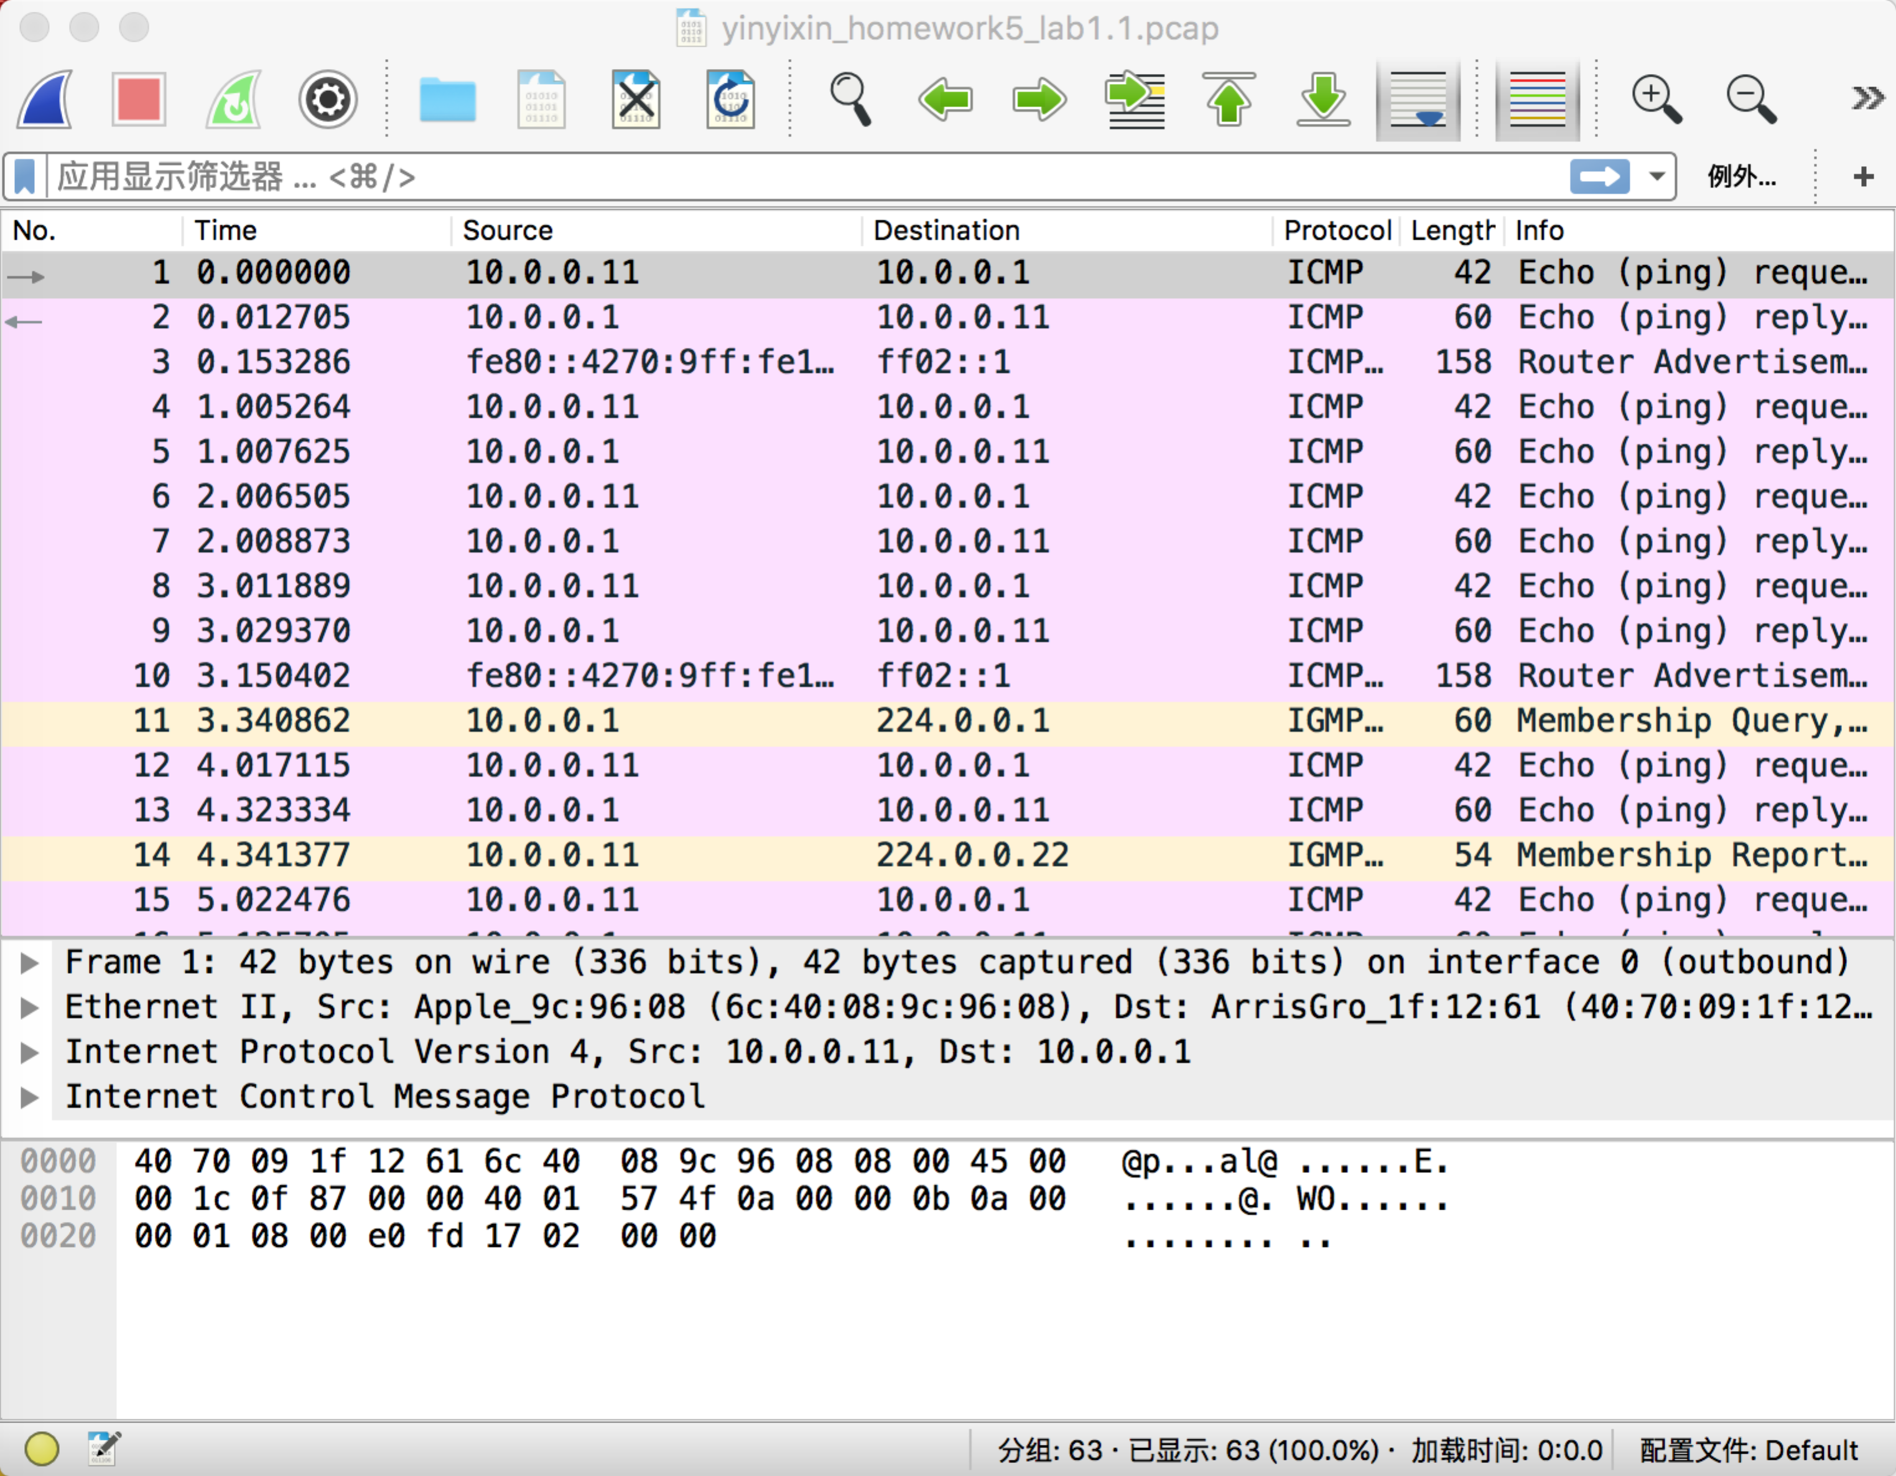

1. TCP/23

sudo hping3 –c 25 -s 5555 10.0.0.1 -p 23

sudo tcpdump -s 0 -w yinyixin_homework5_lab1.2.pcap

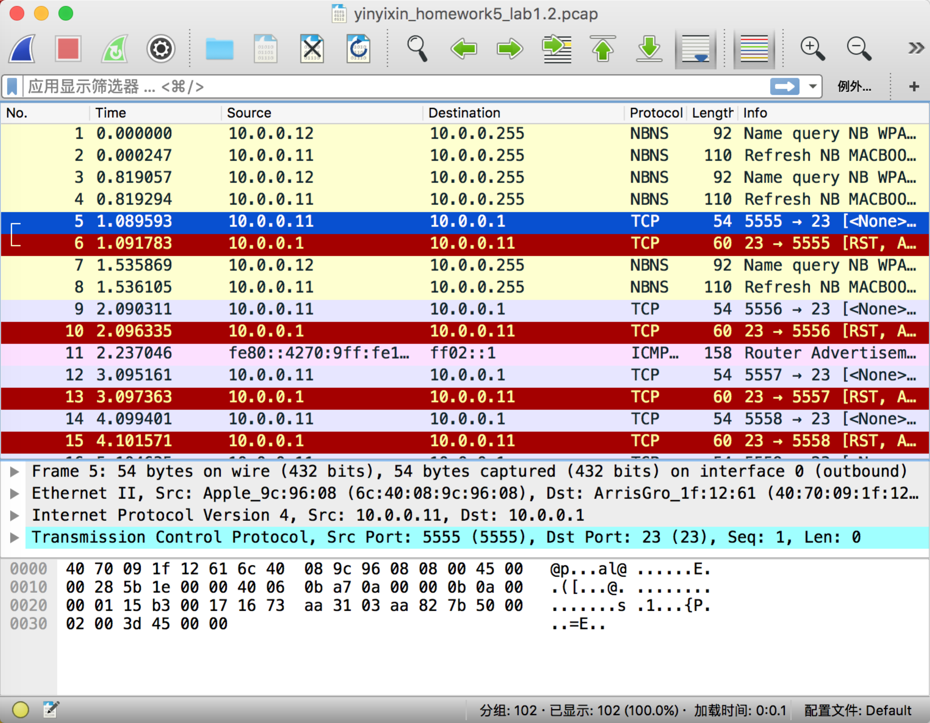

1. TCP/5900

sudo hping3 –c 25 -s 5555 10.0.0.1 -p 5900

sudo tcpdump -s 0 -w yinyixin_homework5_lab1.3.pcap

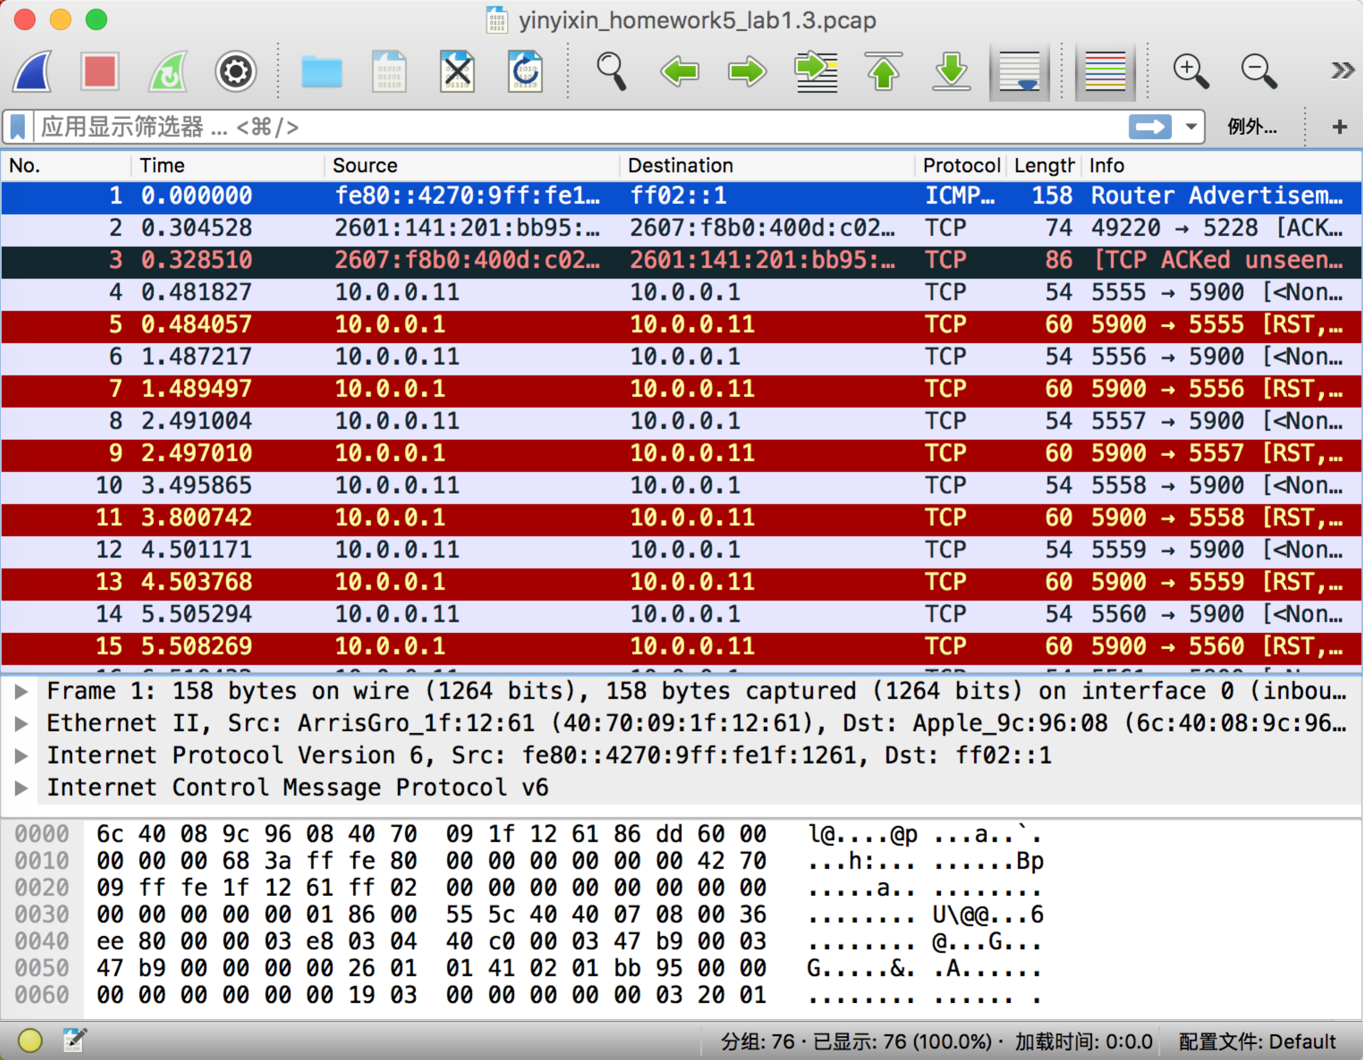

1. UDP/5060

sudo hping3 -2 –c 25 -s 5555 10.0.0.1 -p 5060

sudo tcpdump -s 0 -w yinyixin_homework5_lab1.4.pcap

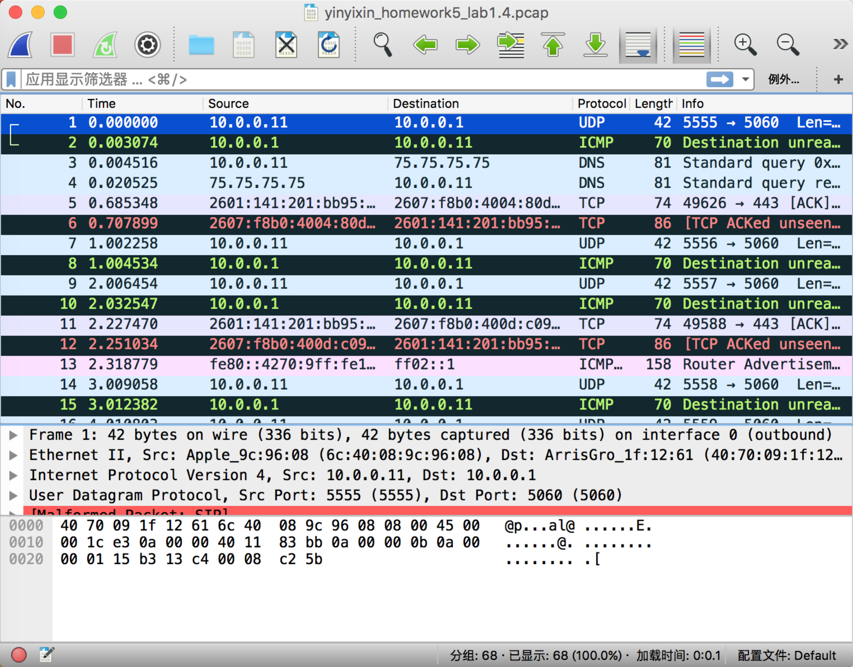

1. TCP/1433

sudo hping3 –c 25 -s 5555 10.0.0.1 -p 1433

sudo tcpdump -s 0 -w yinyixin_homework5_lab1.5.pcap

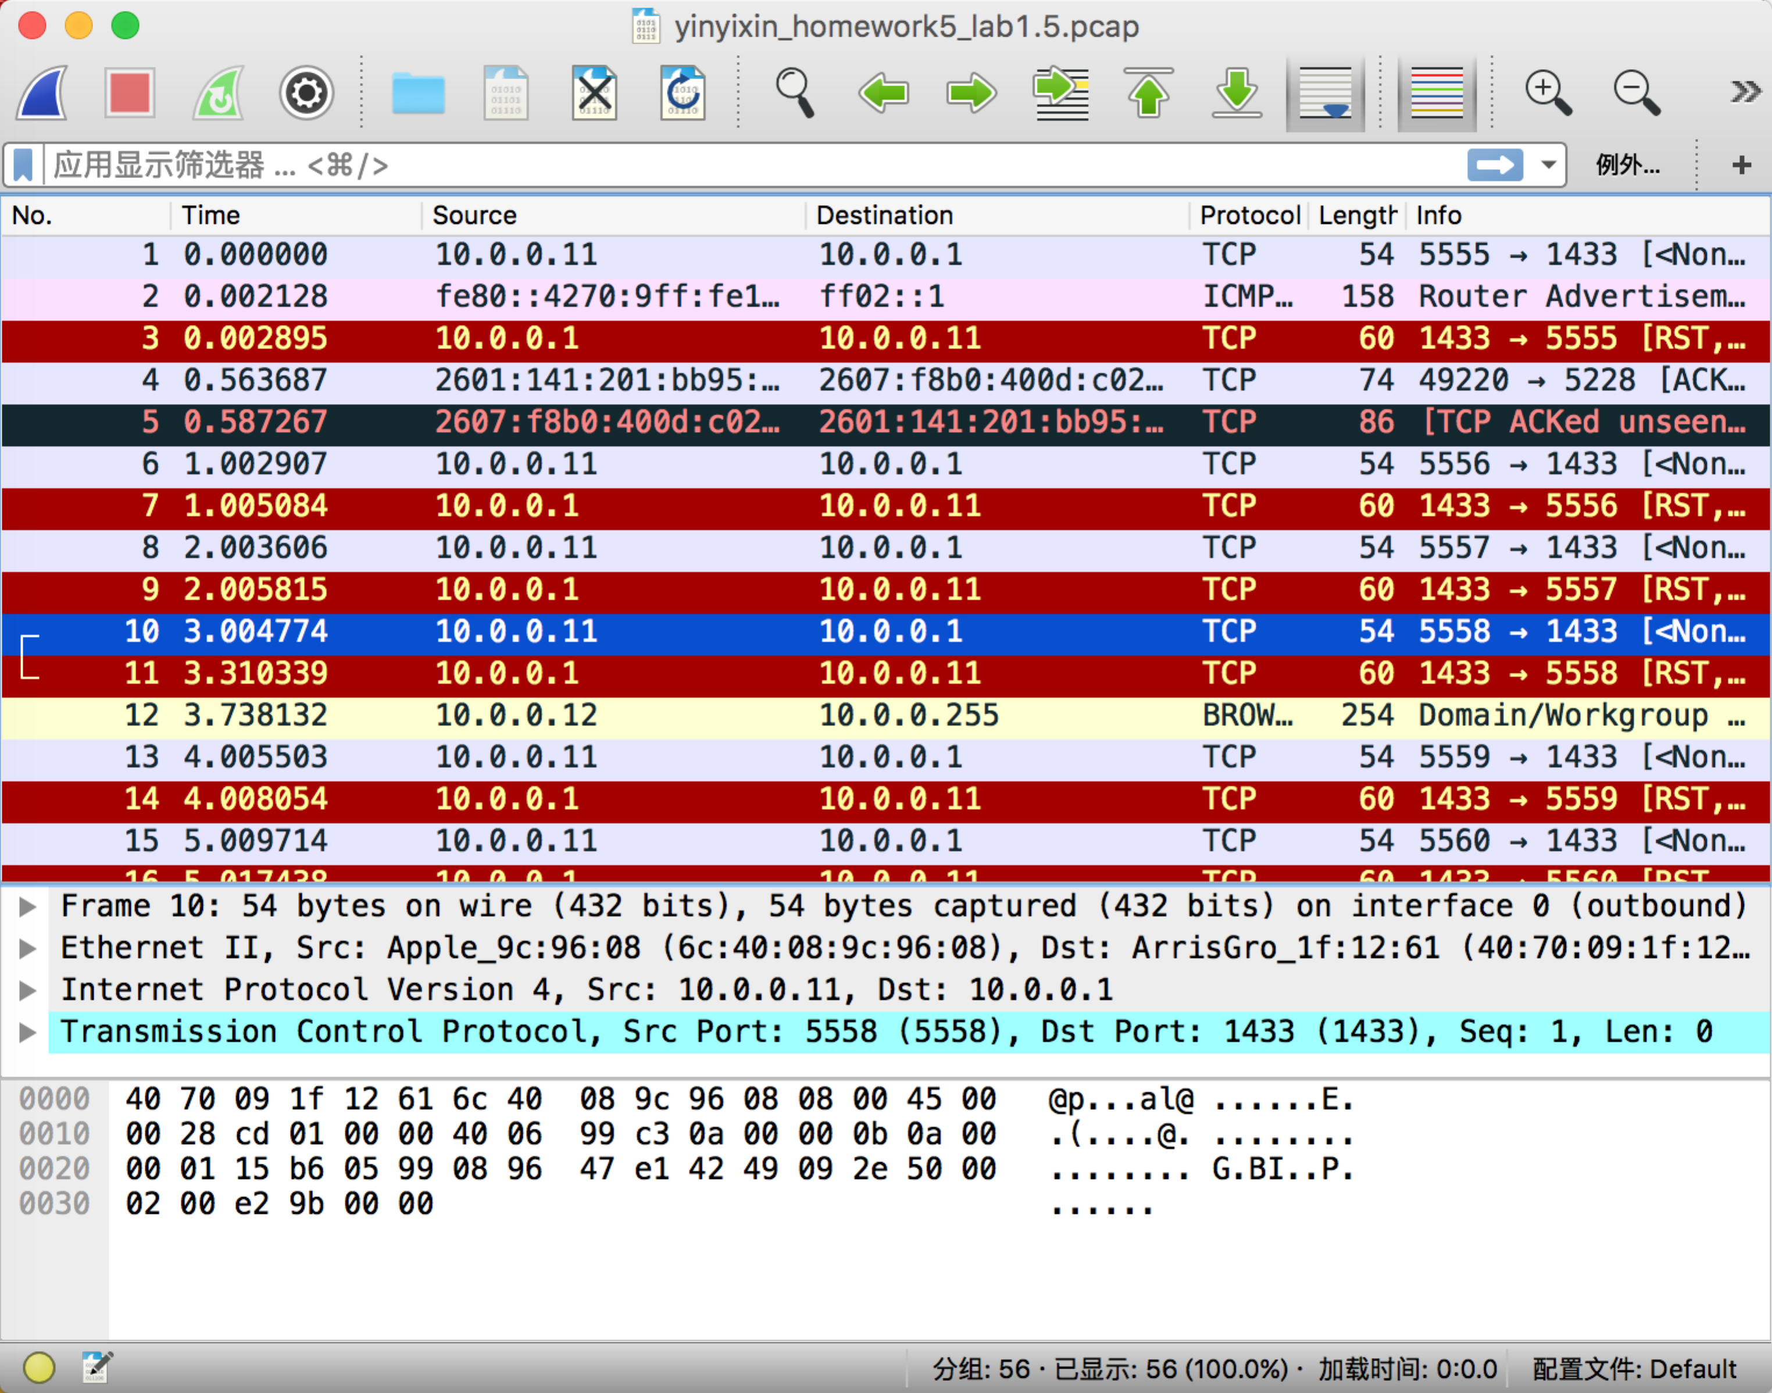

1. UDP/23823

sudo hping3 -2 –c 25 -s 5555 10.0.0.1 -p 23823

sudo tcpdump -s 0 -w yinyixin_homework5_lab1.6.pcap

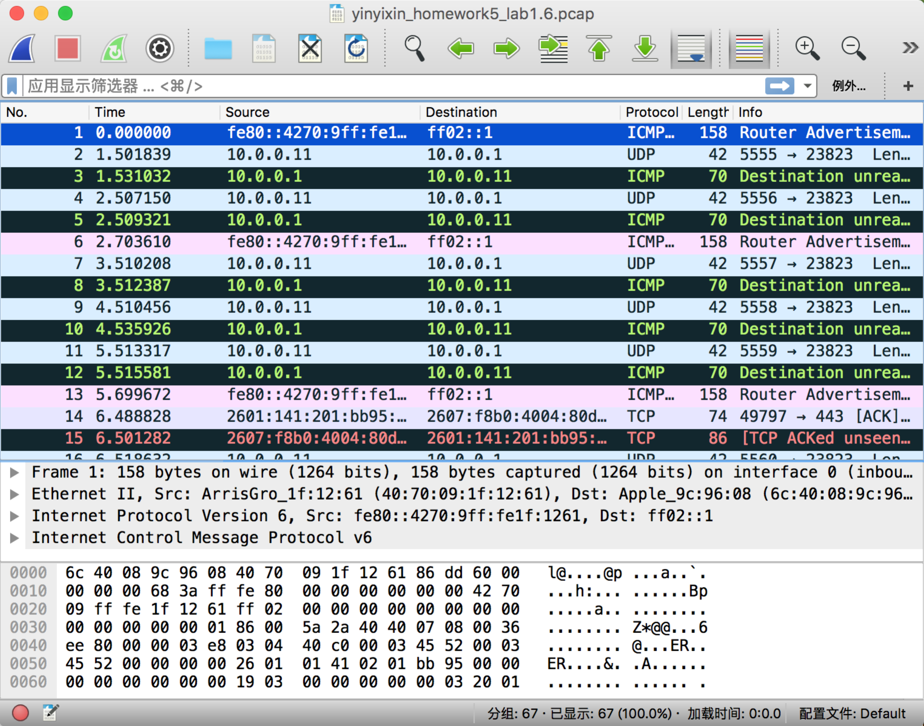

1. UDP/31556

sudo hping3 -2 –c 25 -s 5555 10.0.0.1 -p 31556

sudo tcpdump -s 0 -w yinyixin_homework5_lab1.7.pcap

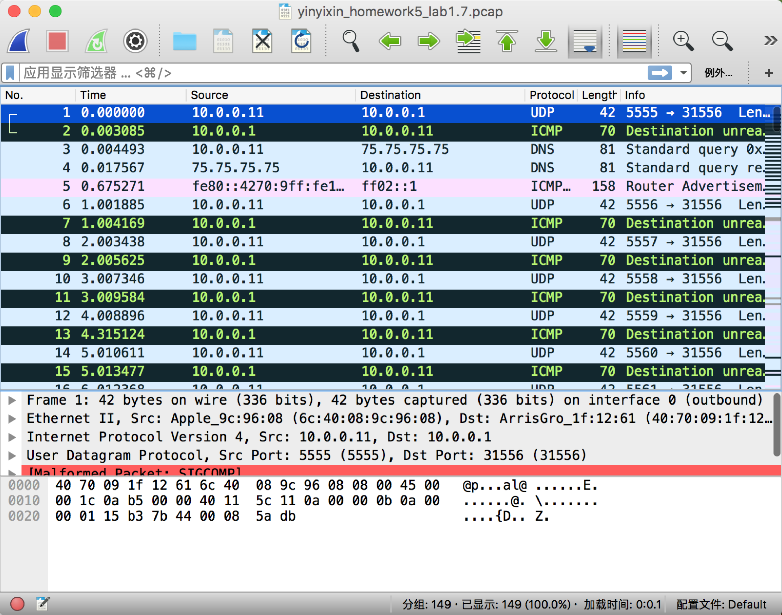

1. UDP/8000

sudo hping3 -2 –c 25 -s 5555 10.0.0.1 -p 8000

sudo tcpdump -s 0 -w yinyixin_homework5_lab1.8.pcap

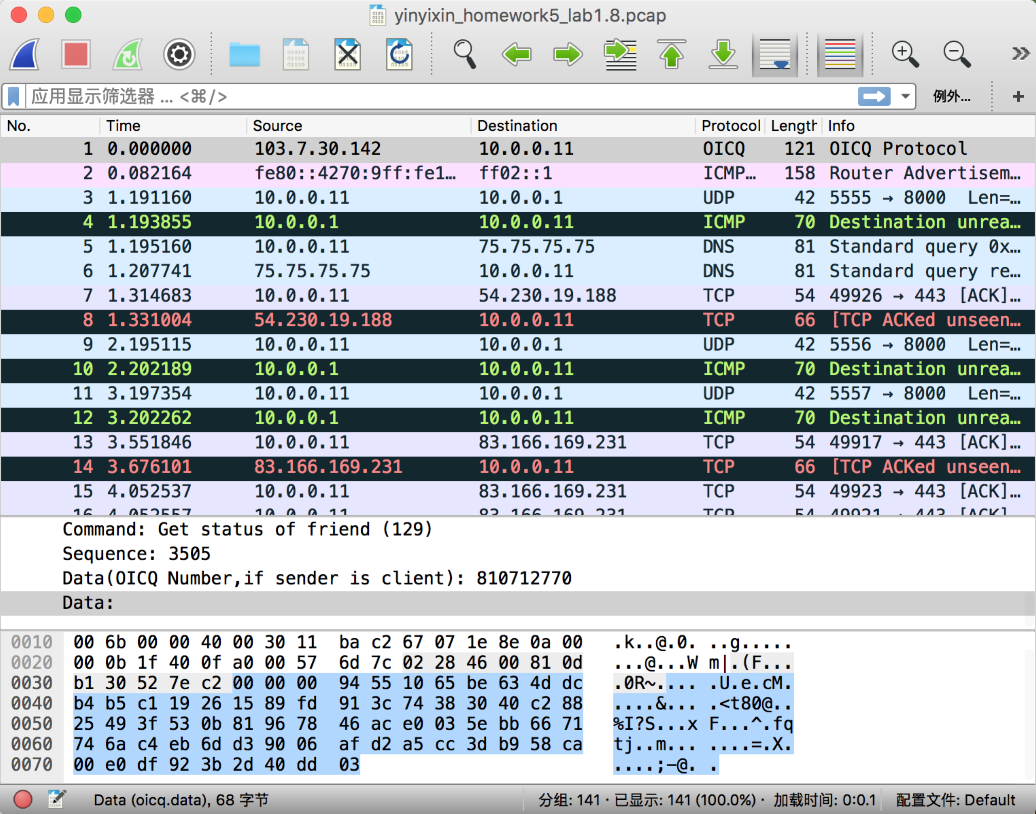

1. TCP/22

sudo hping3 –c 25 -s 5555 10.0.0.1 -p 22

sudo tcpdump -s 0 -w yinyixin_homework5_lab1.9.pcap

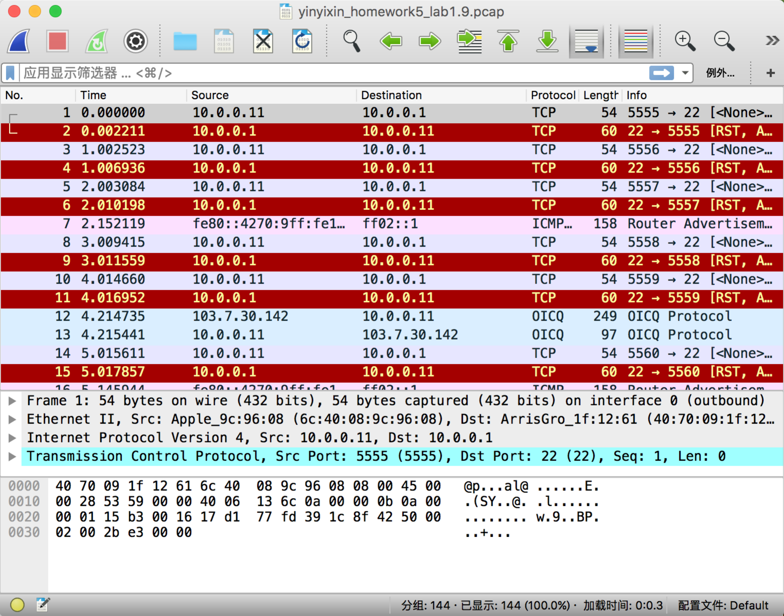

1. TCP/8080

sudo hping3 –c 25 -s 5555 10.0.0.1 -p 8080

sudo tcpdump -s 0 -w yinyixin_homework5_lab1.10.pcap

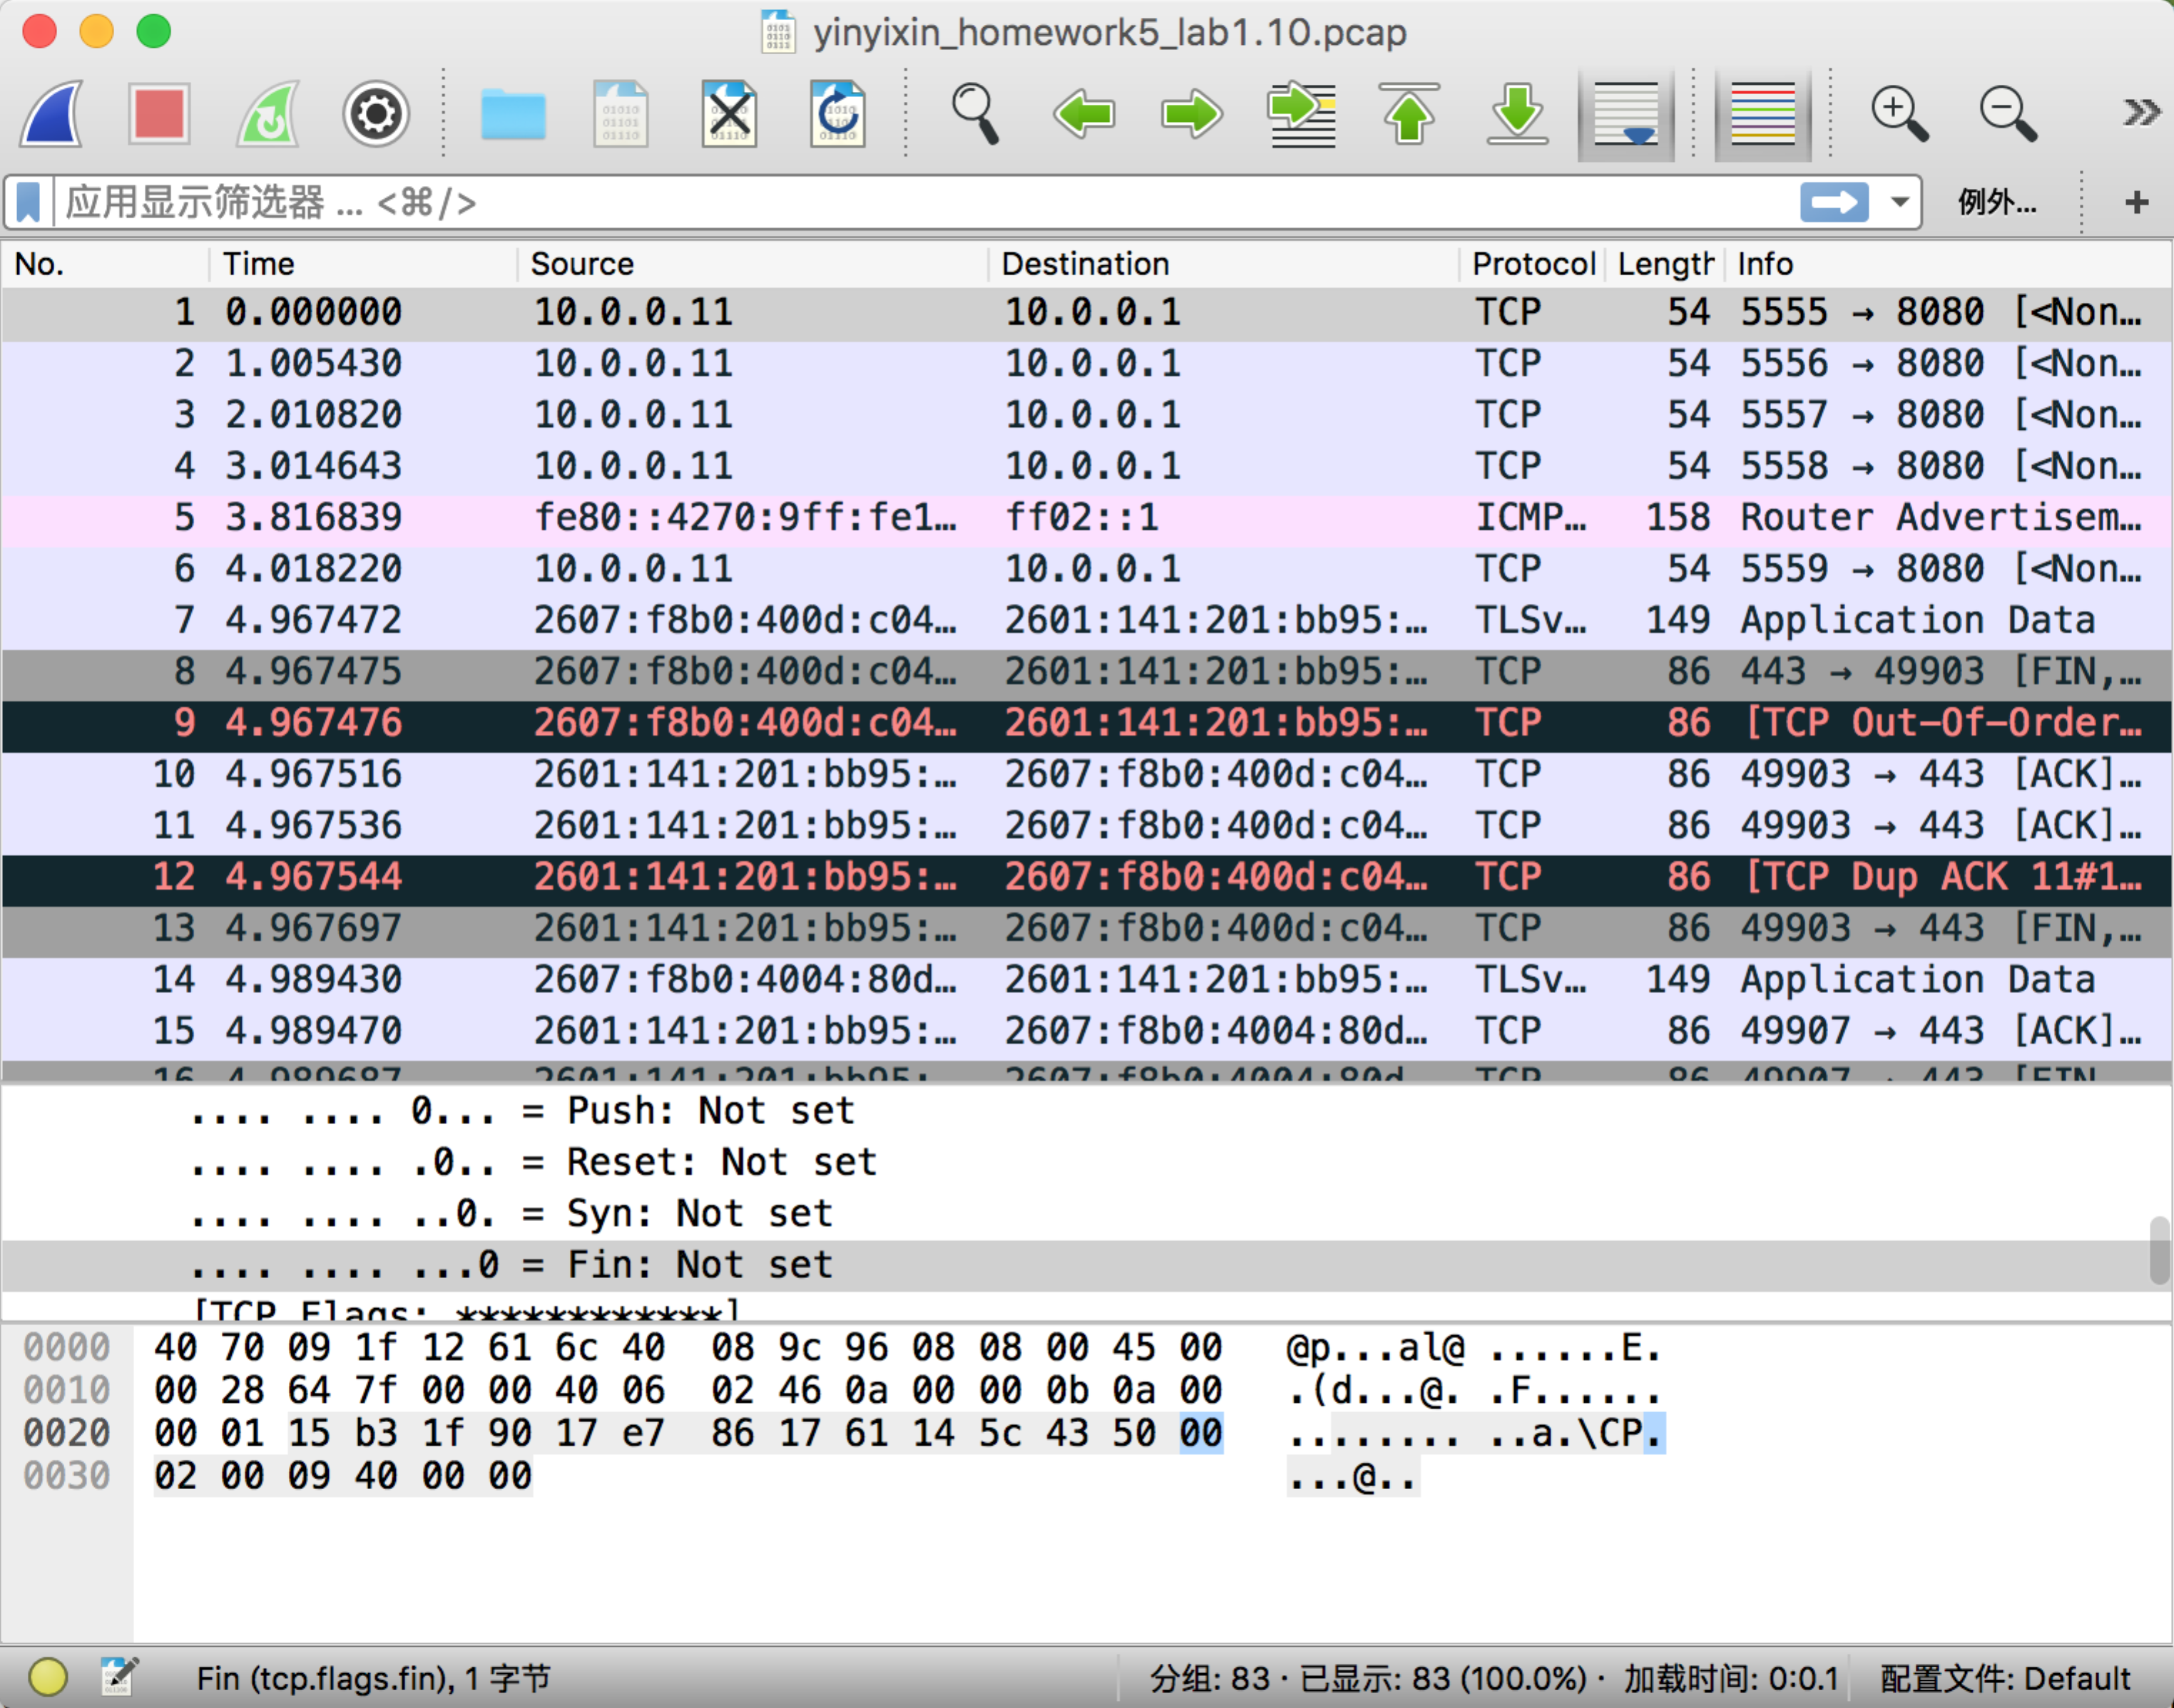

1. TCP 1337

sudo hping3 –c 25 -s 5555 10.0.0.1 -p 1337

sudo tcpdump -s 0 -w yinyixin_homework5_lab1.11.pcap

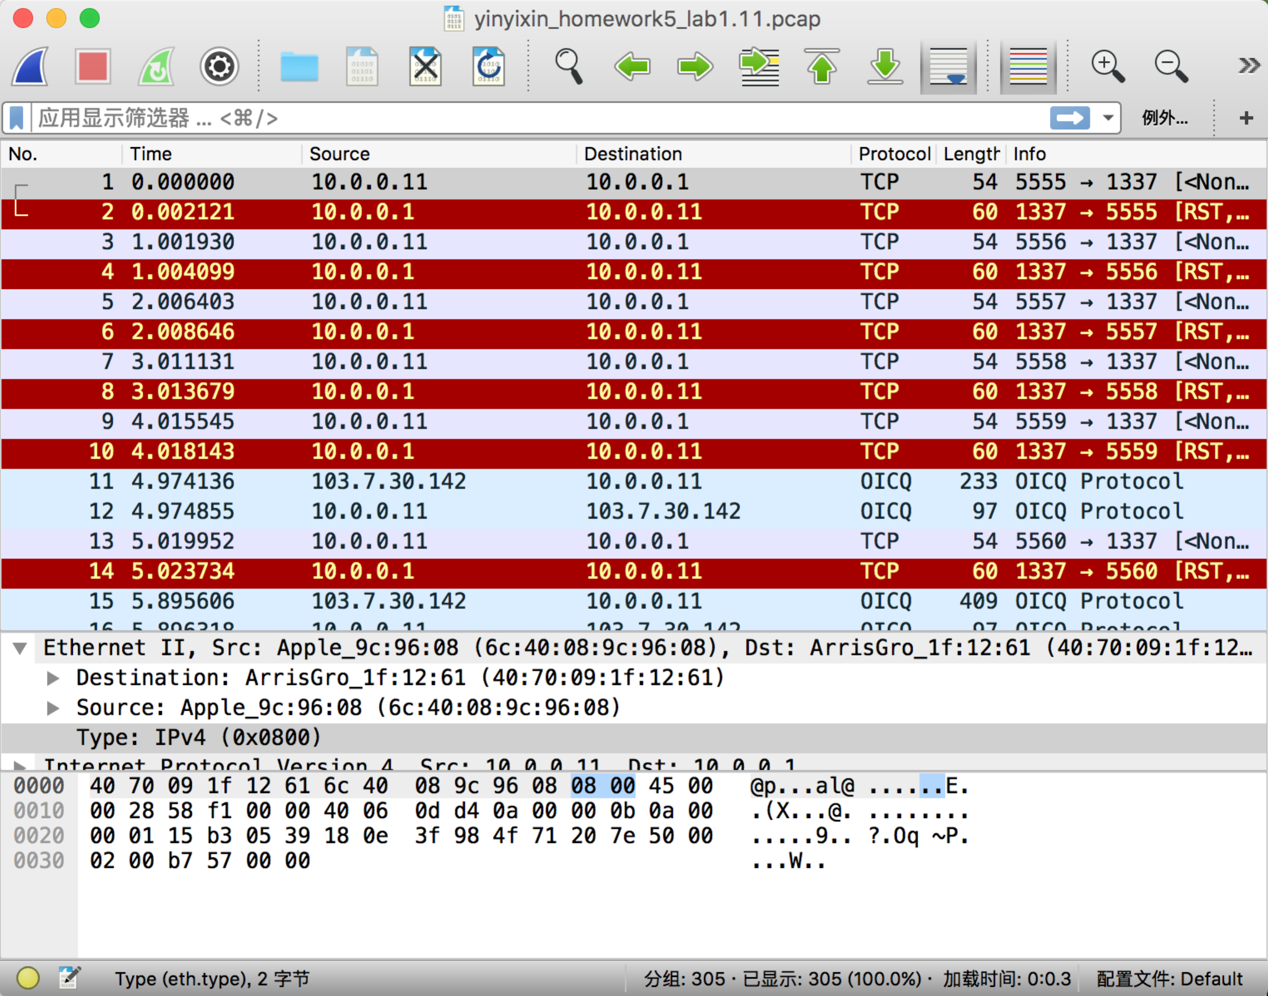

1. TCP/12345

sudo hping3 –c 25 -s 5555 10.0.0.1 -p 12345

sudo tcpdump -s 0 -w yinyixin_homework5_lab1.12.pcap

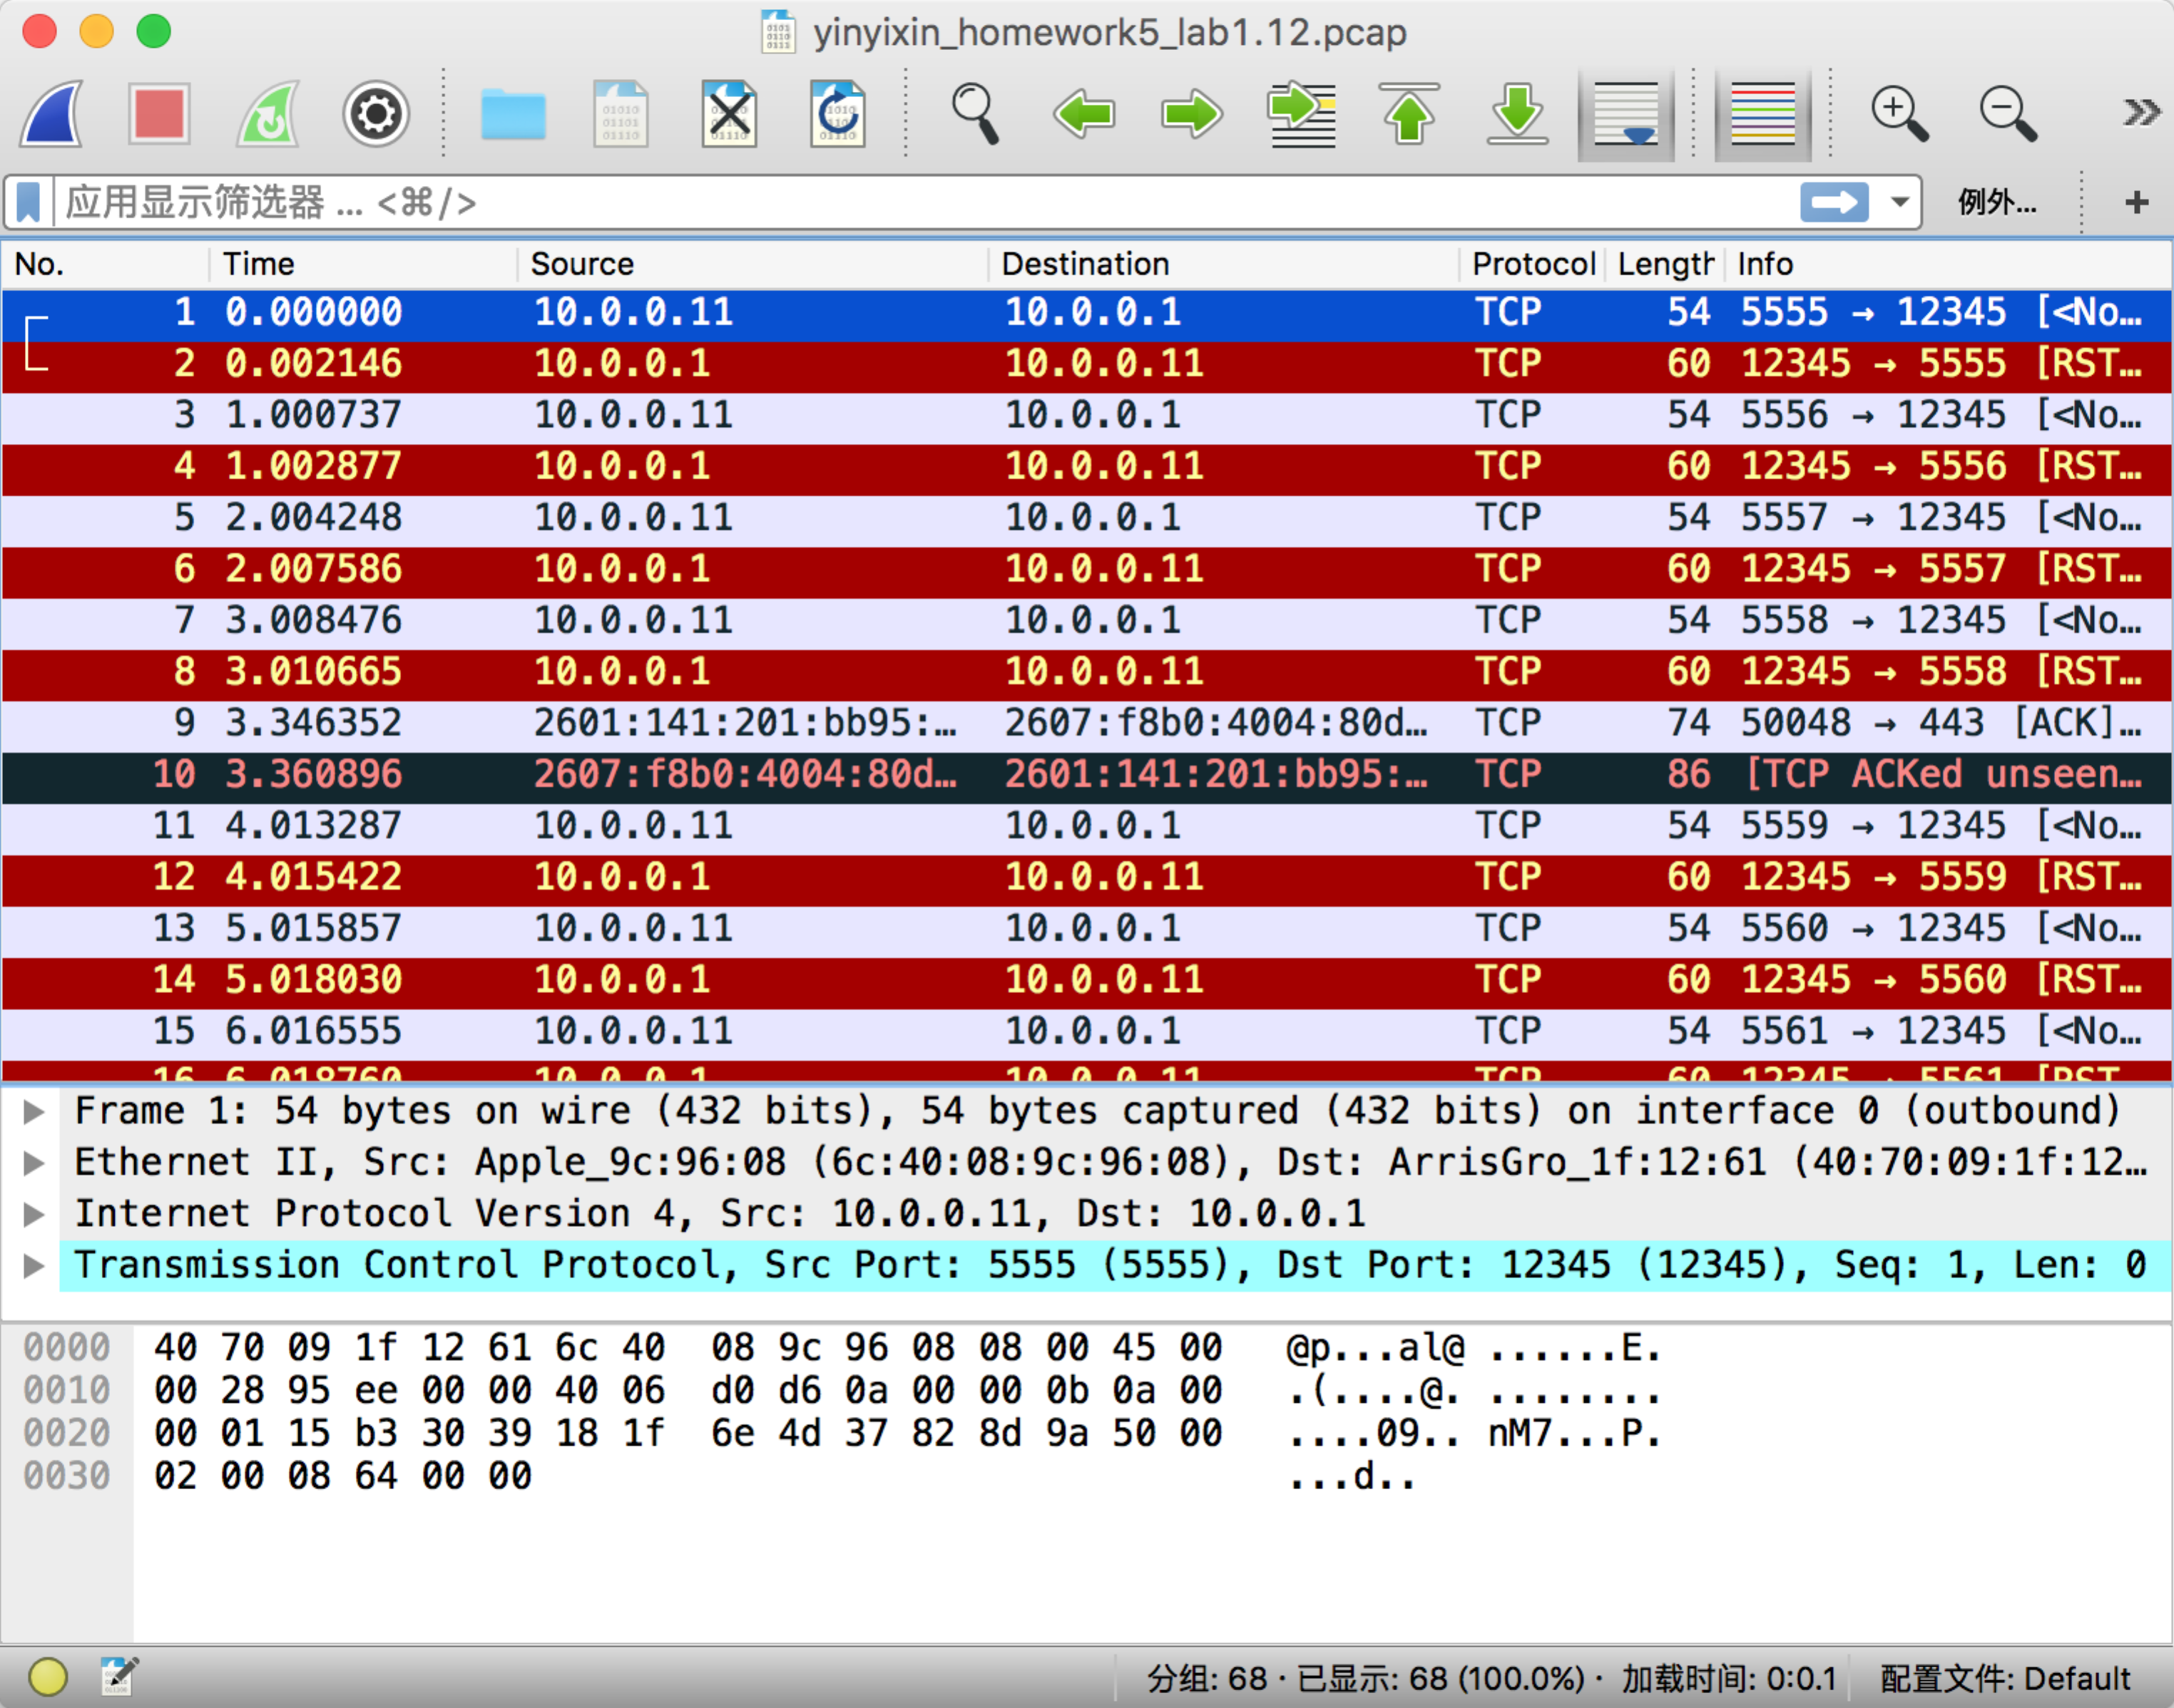

1. TCP/1

sudo hping3 –c 25 -s 5555 10.0.0.1 -p 1

sudo tcpdump -s 0 -w yinyixin_homework5_lab1.13.pcap

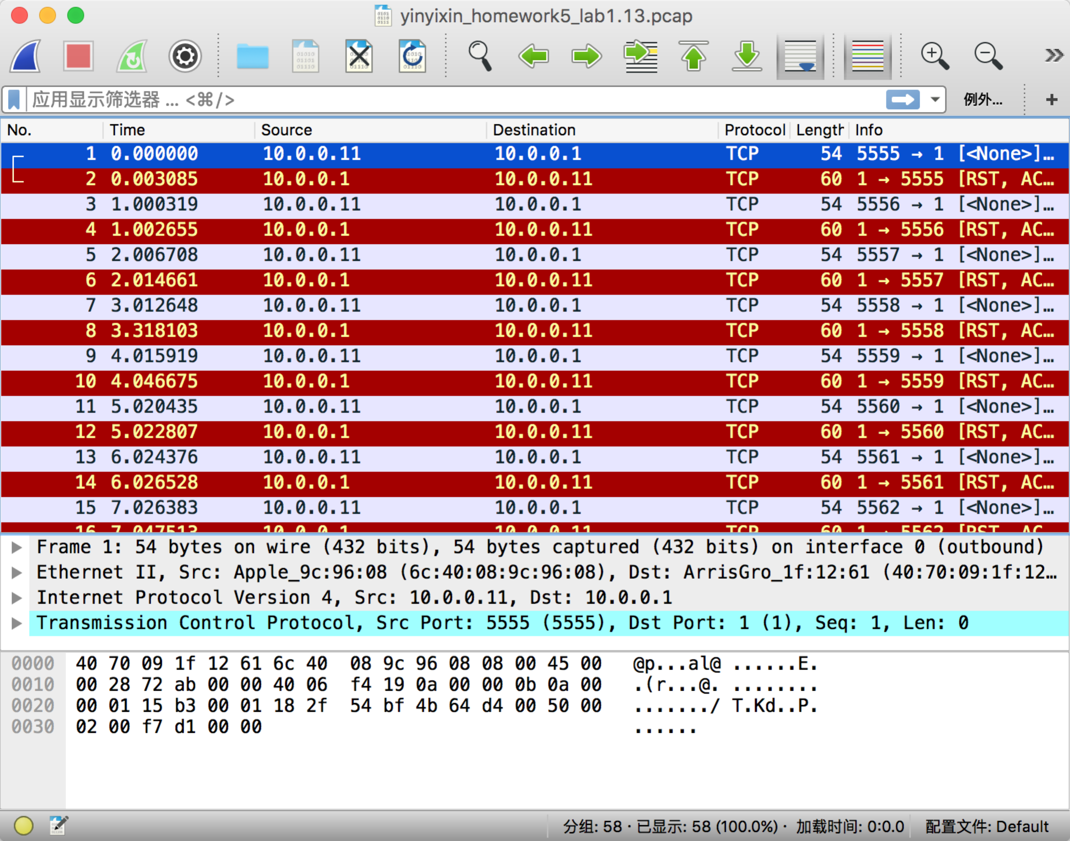

1. UDP/1337

sudo hping3 -2 –c 25 -s 5555 10.0.0.1 -p 1337

sudo tcpdump -s 0 -w yinyixin_homework5_lab1.14.pcap

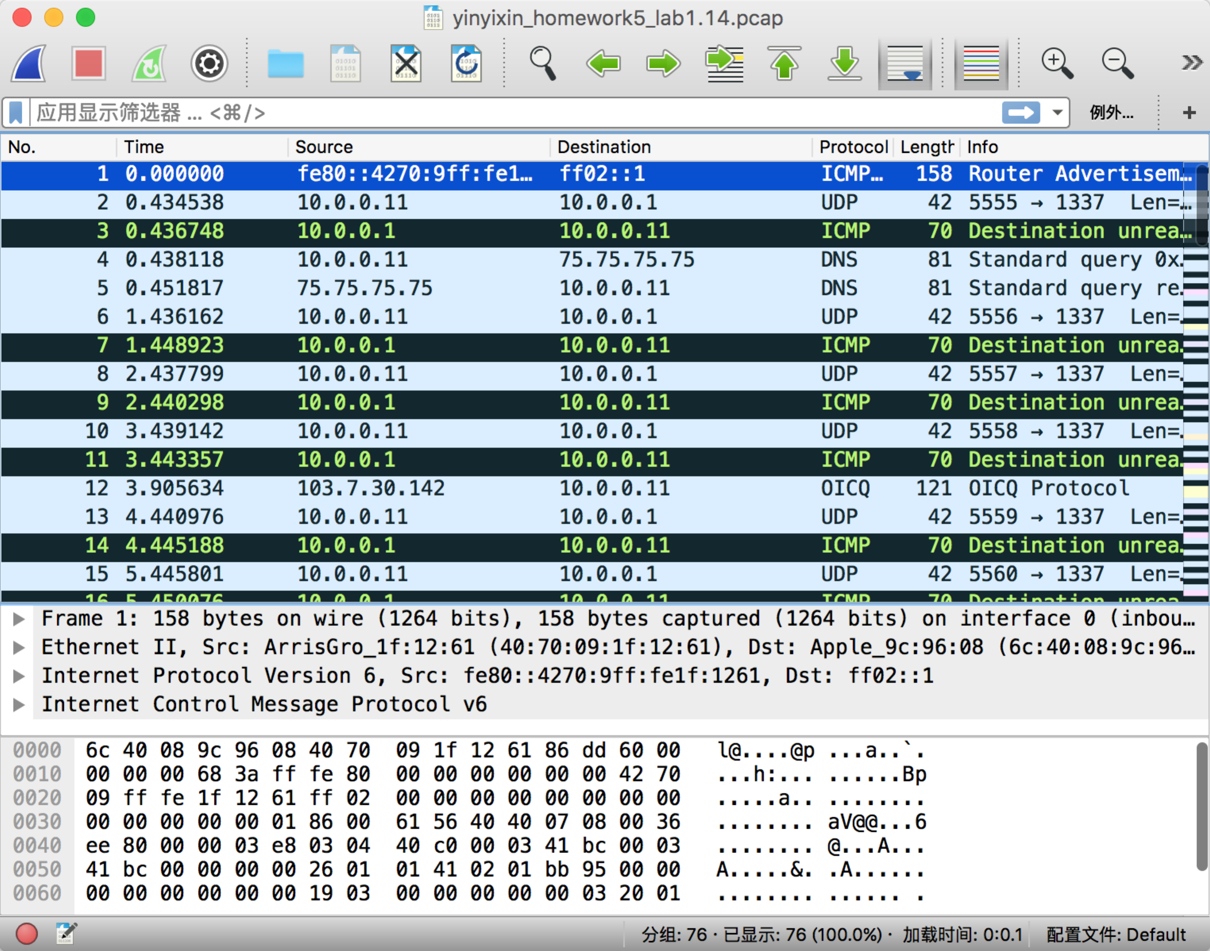

1. UDP/53 IT IS DNS PROTOCOL

sudo hping3 -2 –c 25 -s 5555 10.0.0.1 -p 53

sudo tcpdump -s 0 -w yinyixin_homework5_lab1.15.pcap

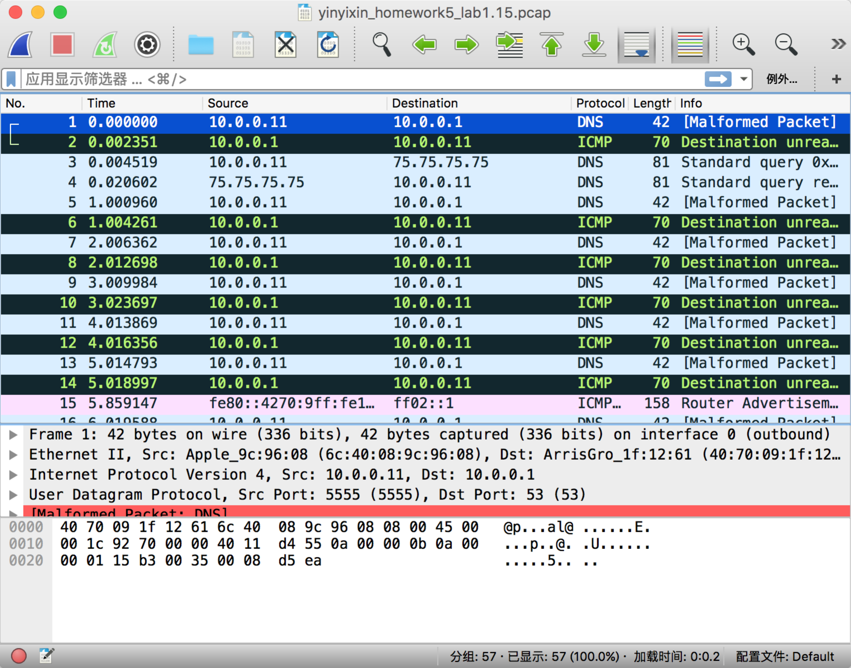

2.

nmap scan the top 1000 “most common” ports.

Here is the command I used to show the results. I used the commands to scan google’s port condition. Because it contains 1000 ports, so I store the output in a .txt file.

sudo nmap -dd [www.google.com](http://www.google.com)

sudo tcpdump -s 0 -w yinyixin_homework5_lab2.pcap

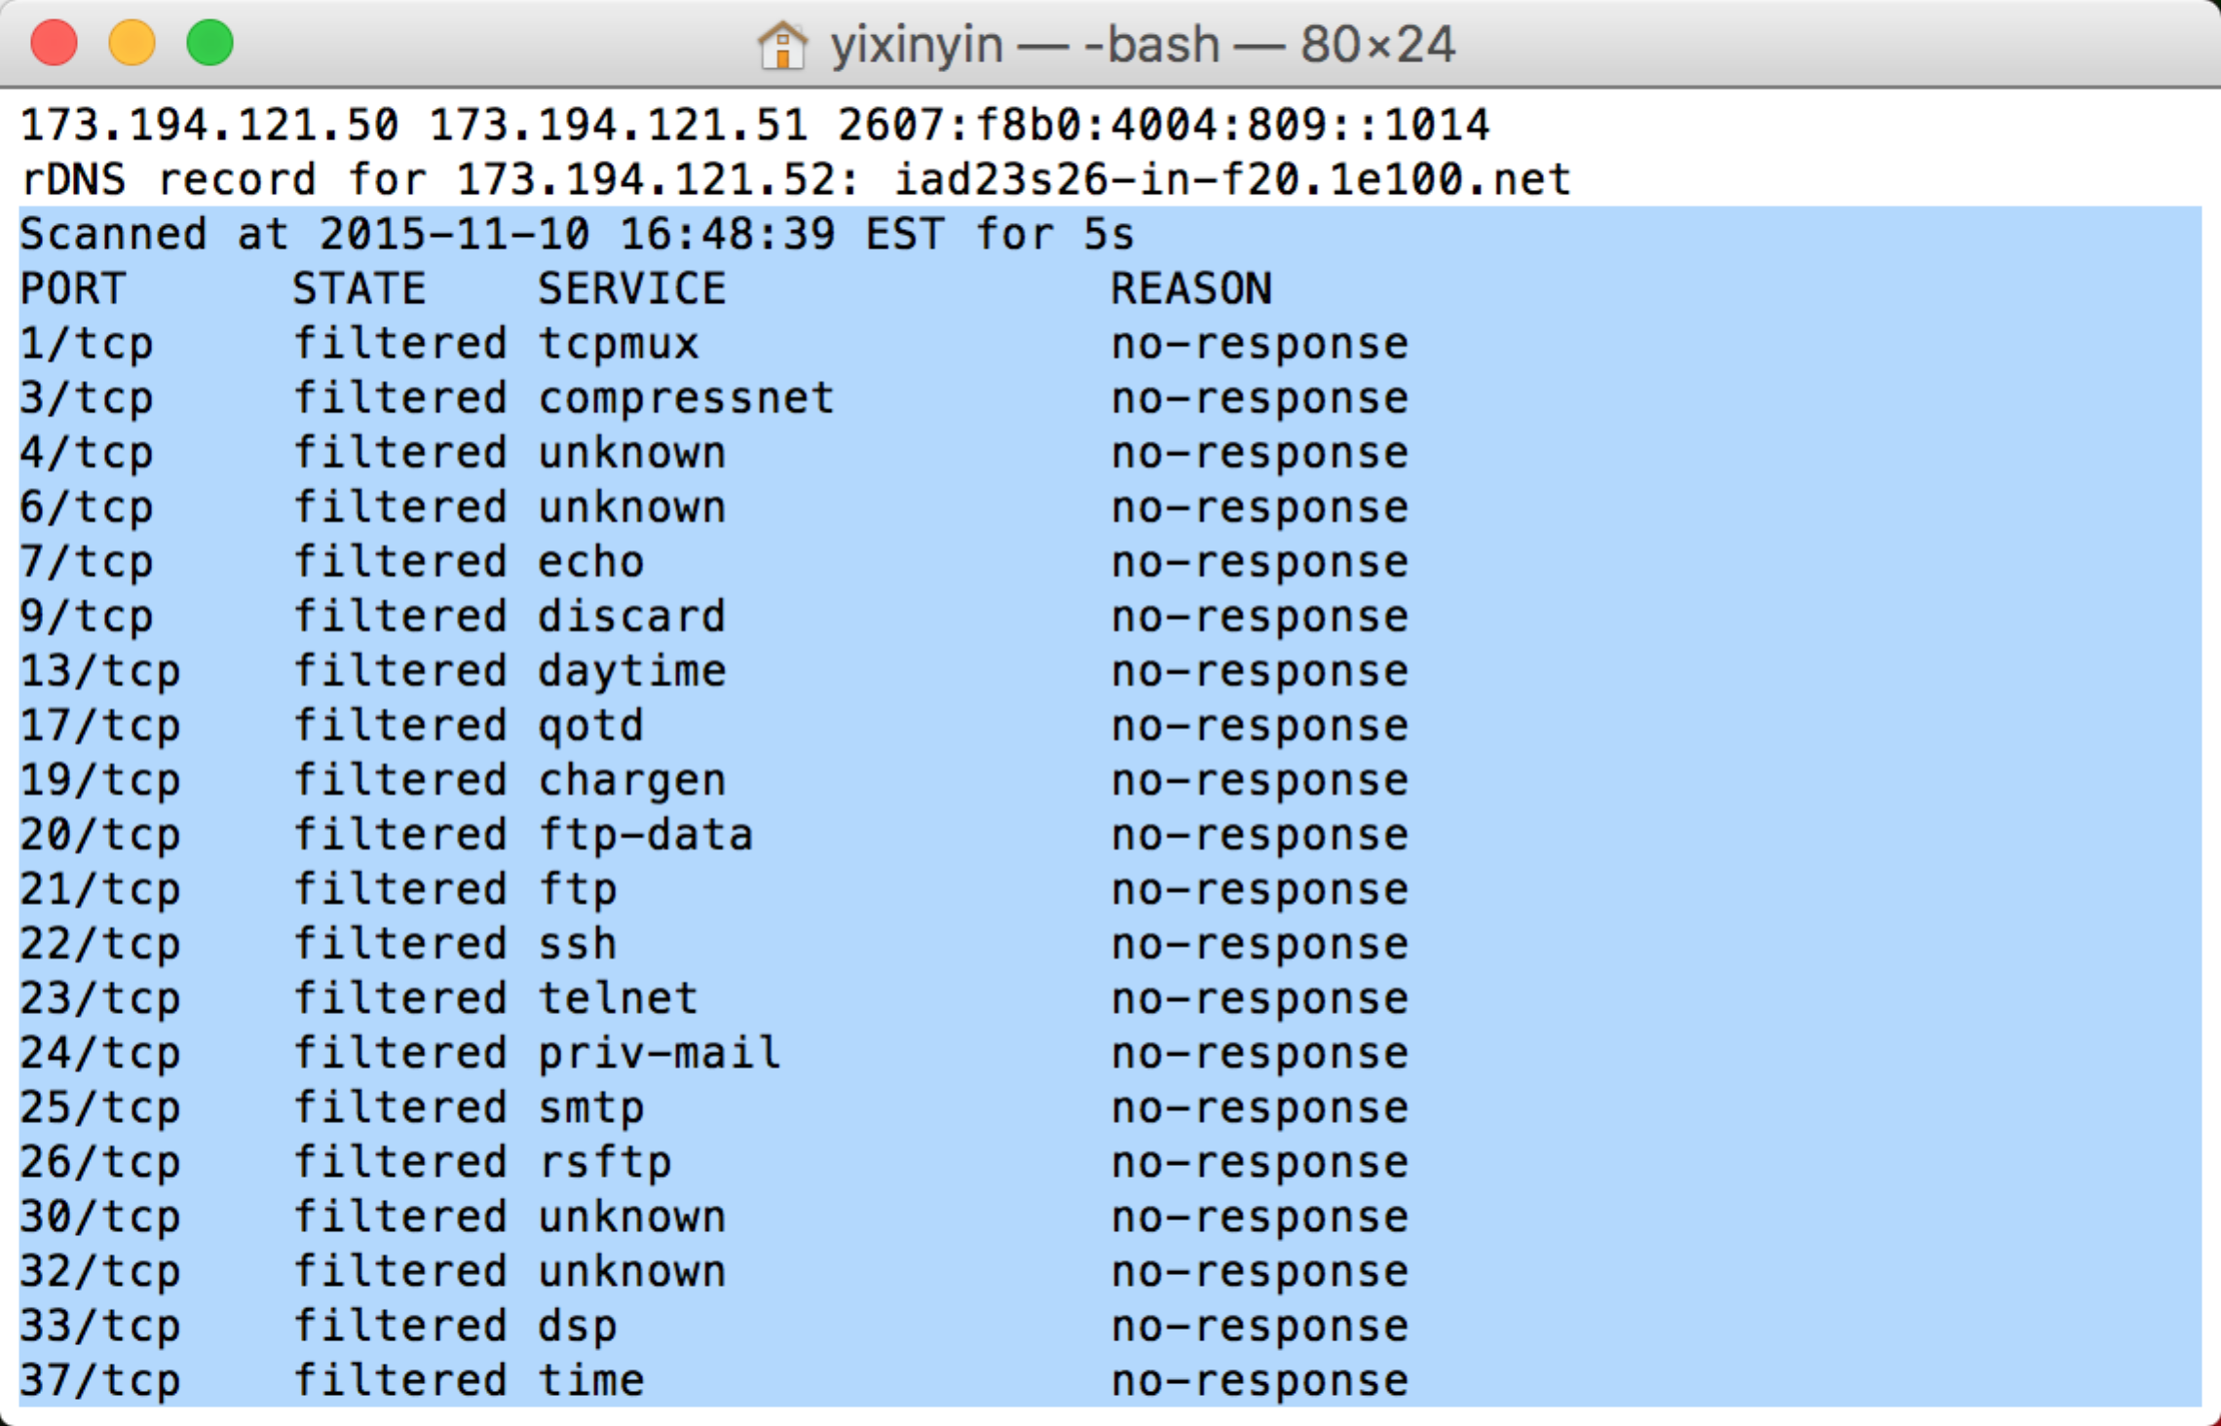



only 443/TCP and 80/TCP ports are open.

The results is the same with the normal scan. We use nmap [www.google.com](http://www.google.com) and we get:

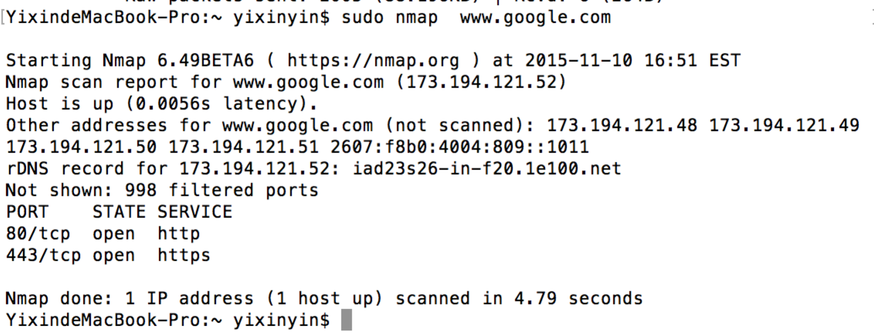

998 filters ports and 2 open ports

Here is the screeshot of the pcap file. The address of [www.google.com](http://www.google.com) is 173.194.205.105.

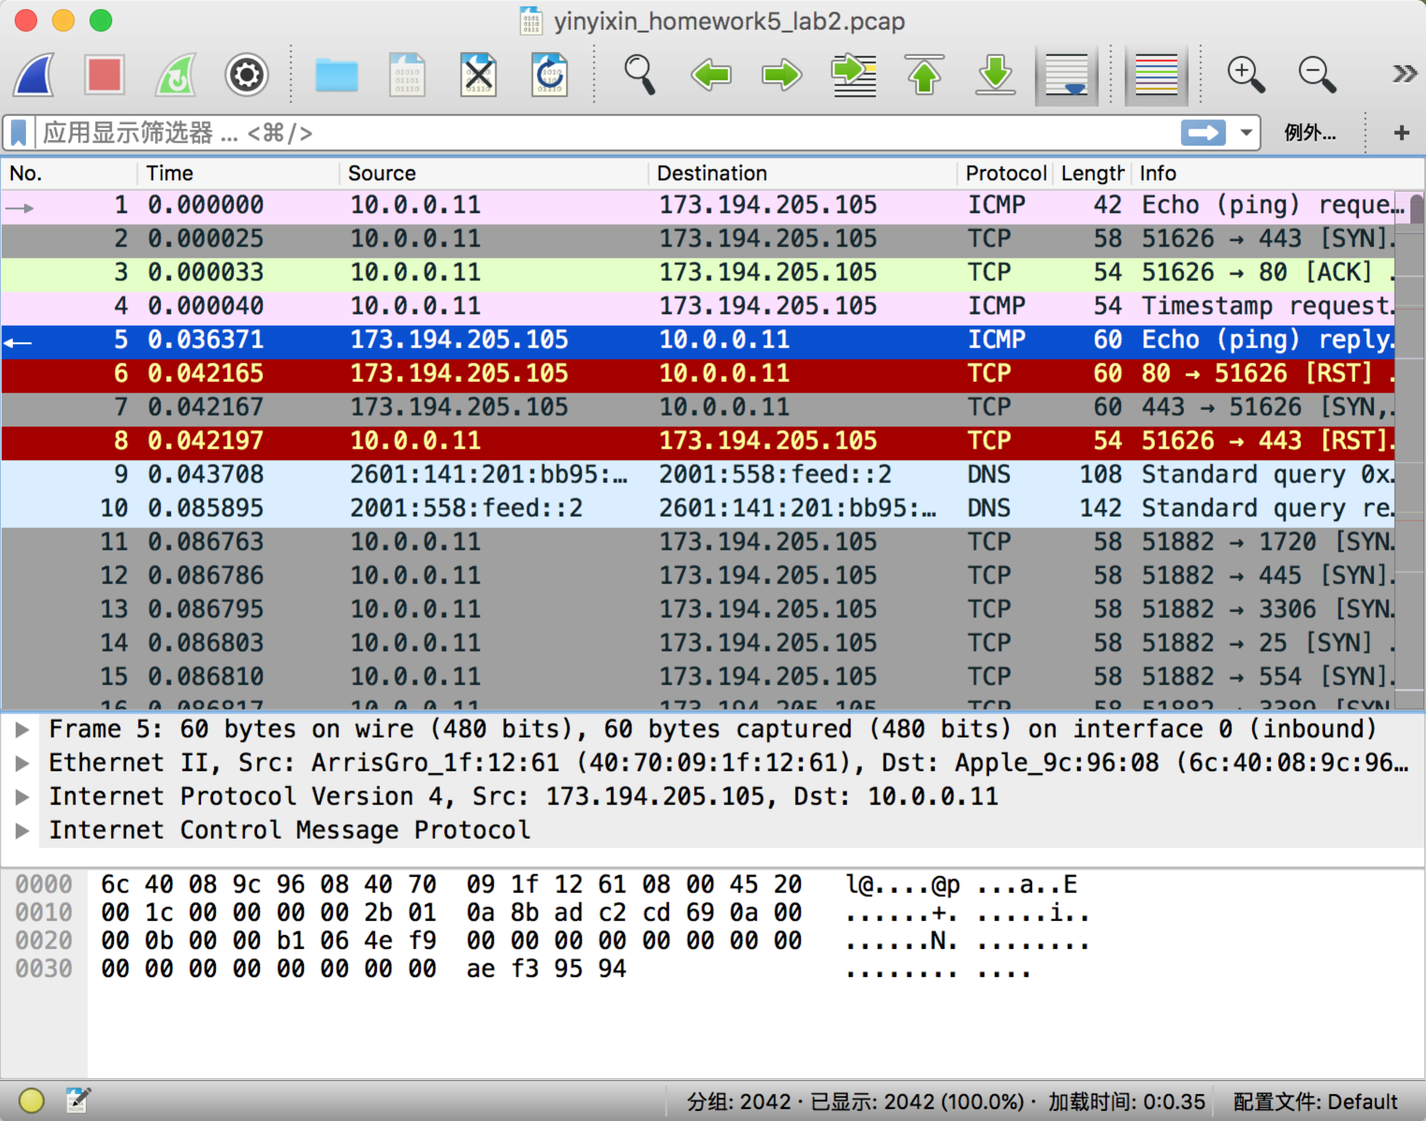

3.

I use the example.com domain to test.

Here is the domain : <http://www.example.com/>

The IP address is 93.184.216.34

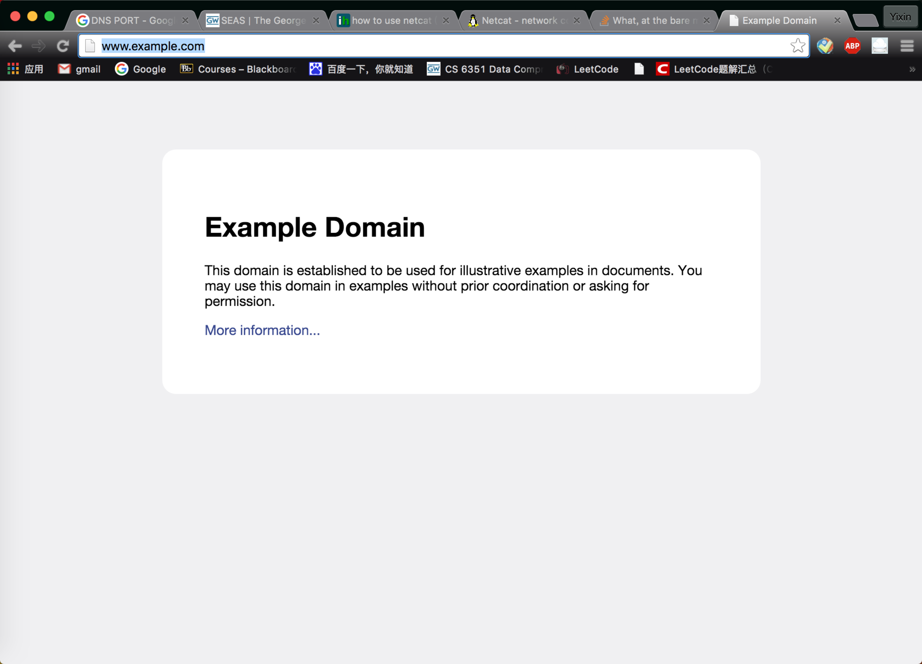

First we need to retrieve the webpage. We need use the following command:

We need to open 3 terminal:  
For terminal 1:

mkfifo backpipe

netcat -l -p 9999 0<backpipe |printf 'GET / HTTP/1.1\r\nHost: www.example.com\r\n\r\n' | netcat www.example.com 80 1>backpipe

For terminal 2: (we use telnet to test the 9999 port)

telnet localhost 9999

For terminal 3:

sudo tcpdump -s 0 -w yinyixin_homework5_lab3.pcap

And we get the following screenshot in terminal 2:  
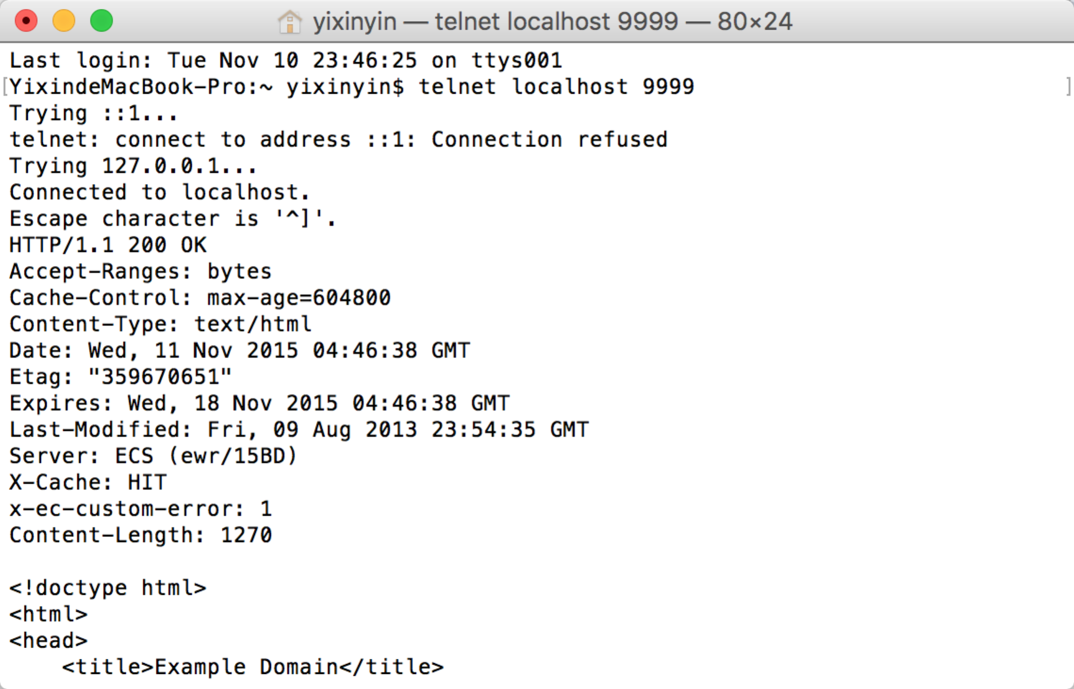

So it shows that we finish the task.  
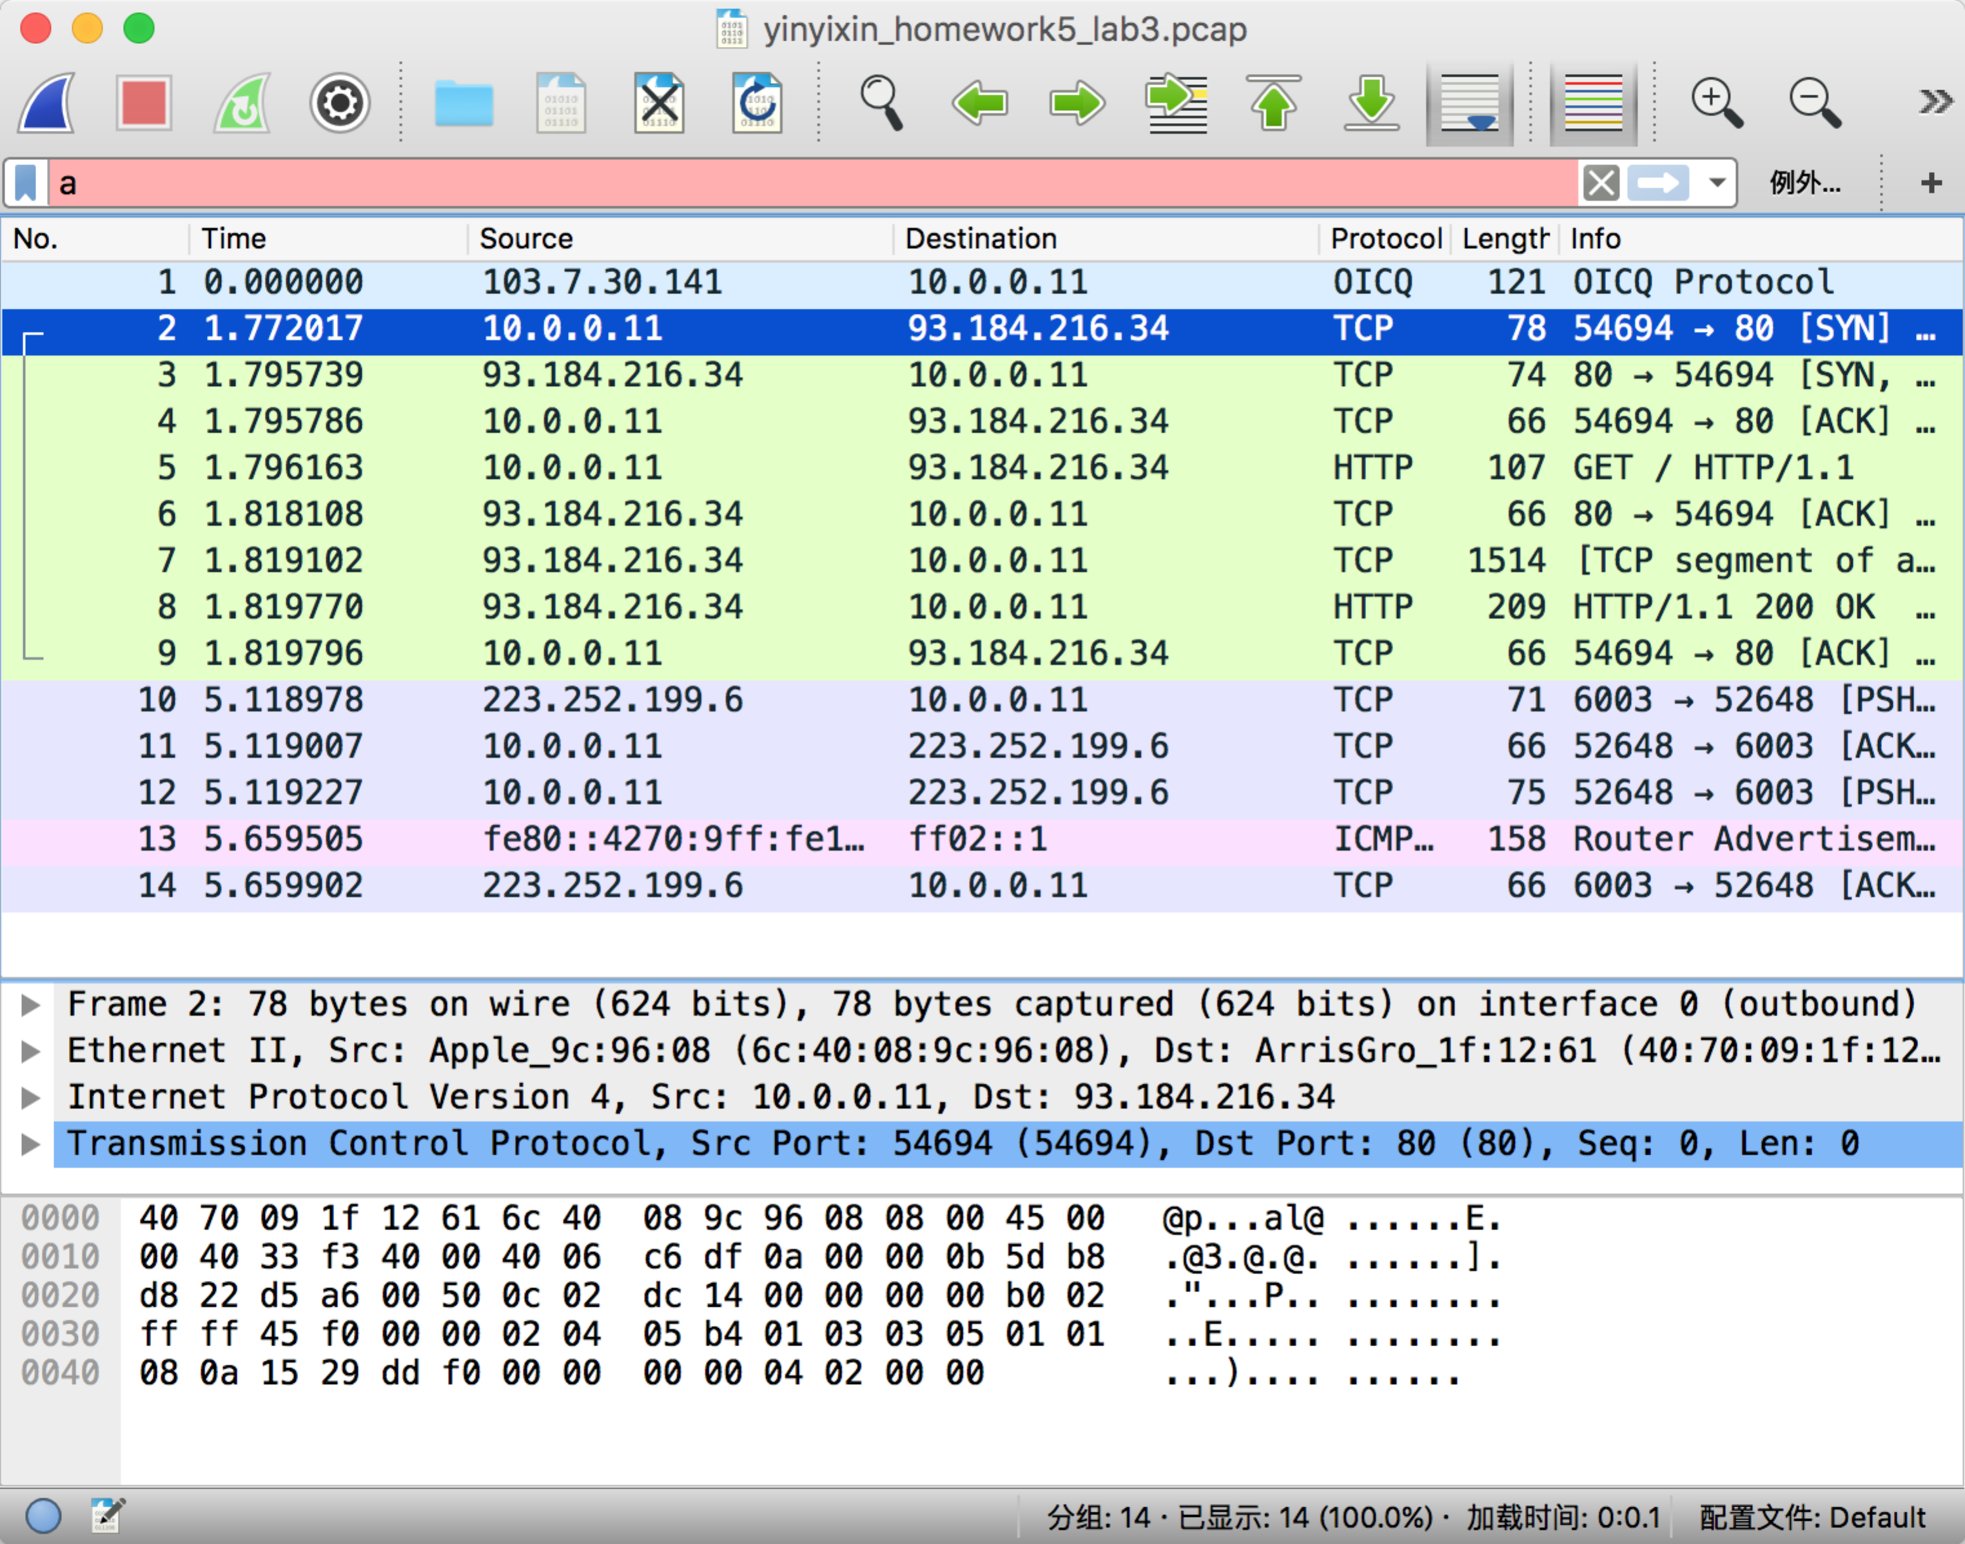

4.

I use libnet and C language to send the DNS response. I make the DNS ip address as arguments so user can set them in the code. The code is based on the libnet example in our ppt of chapter 6

In this question, we need to write DNS response and make the payload as the requirements. Here is the format I use:  
Destination ip address is 127.0.0.1

Source ip address is 10.0.0.11

The DNS response has queries field, answers field and authoritative nameservers field.

Note that in Xcode you need to link the libnet.a library to use libnet.

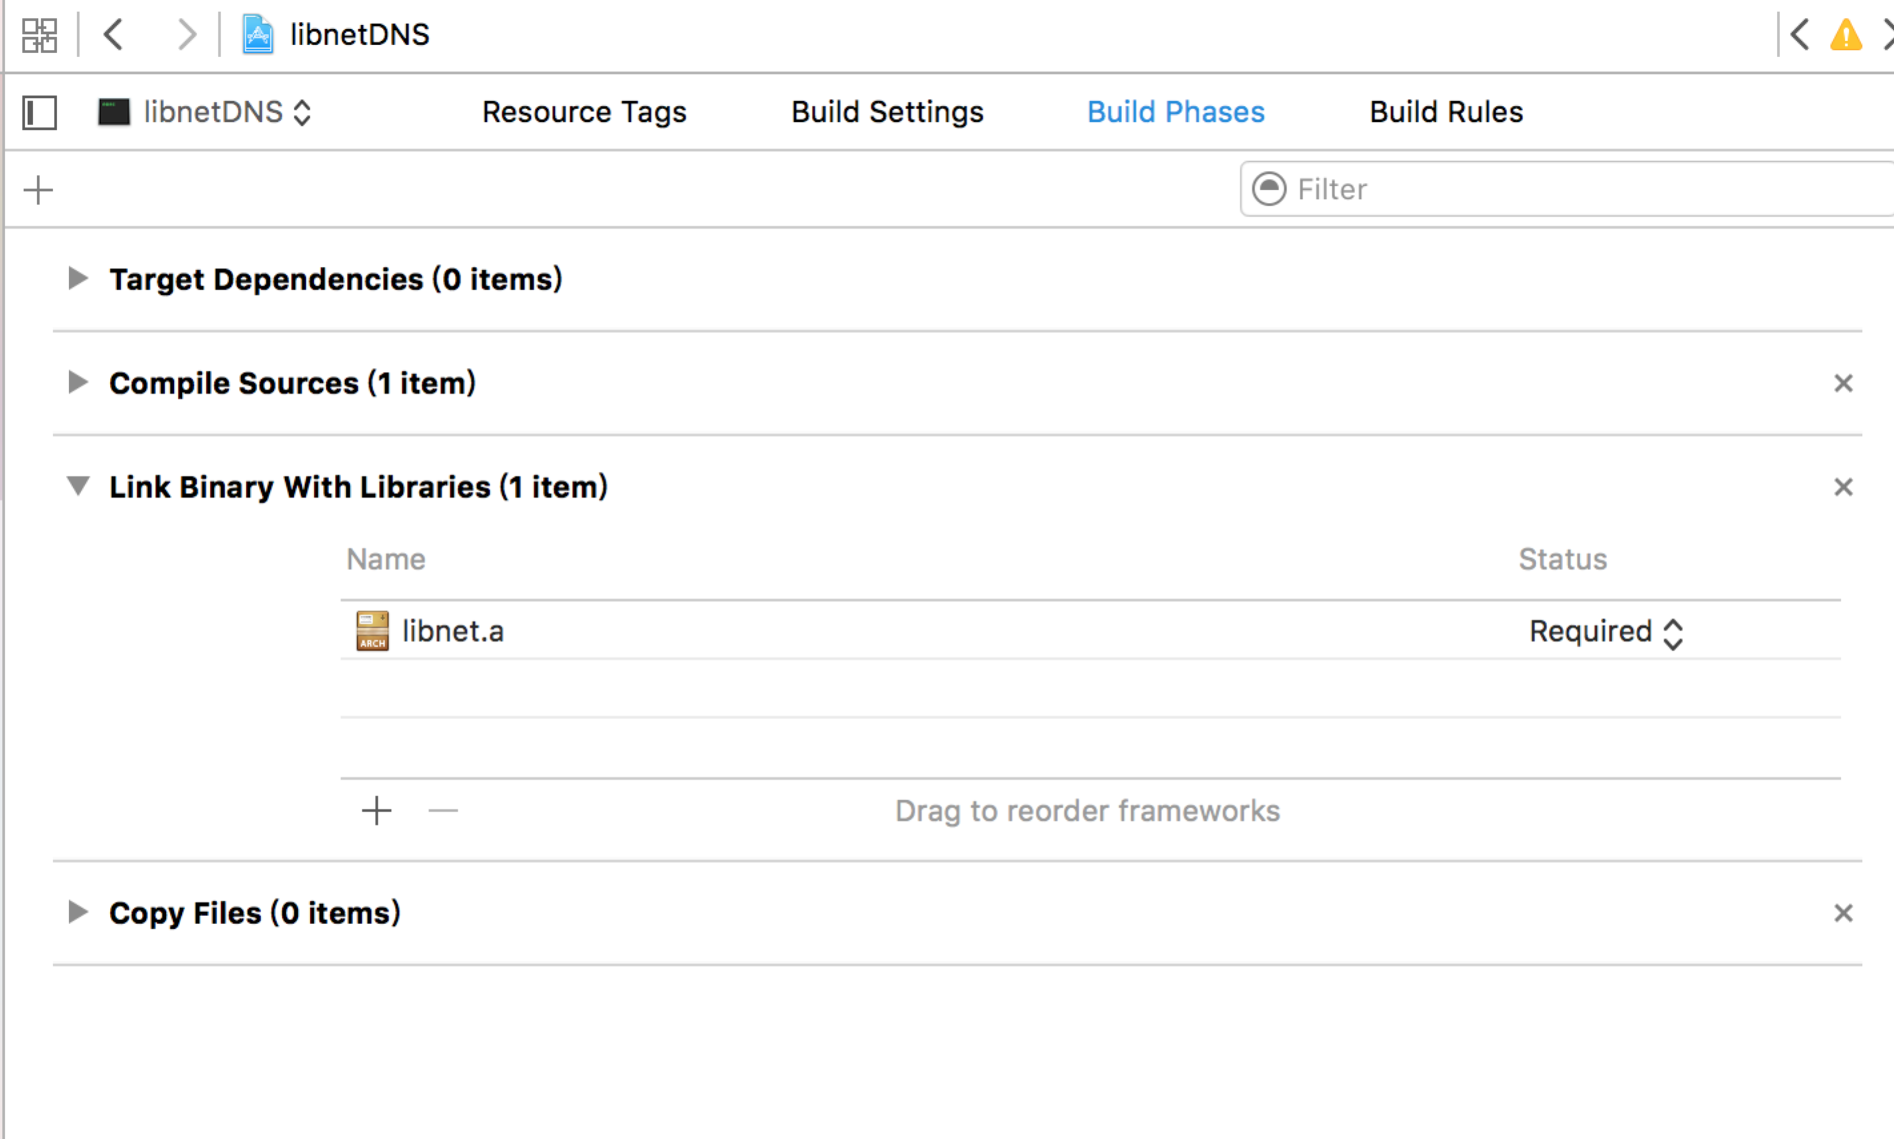

I generate the payload in the following way:

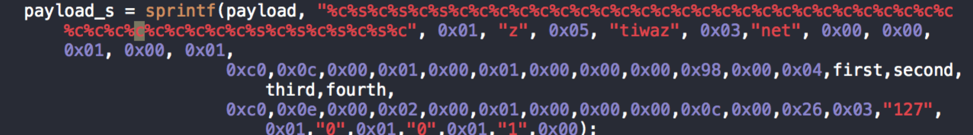

this set the DNS queries, answers and authoritative rrs.

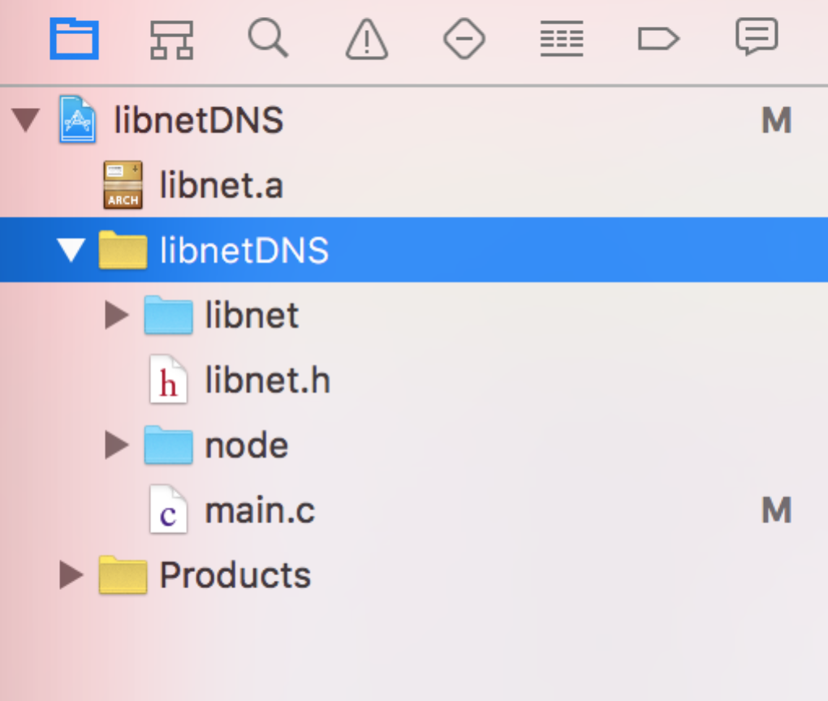

Then I run tcpdump and get the packets.

sudo tcpdump -s 0 -w yinyixin_homework5_lab4.pcap

Here is the 100 packets I got.

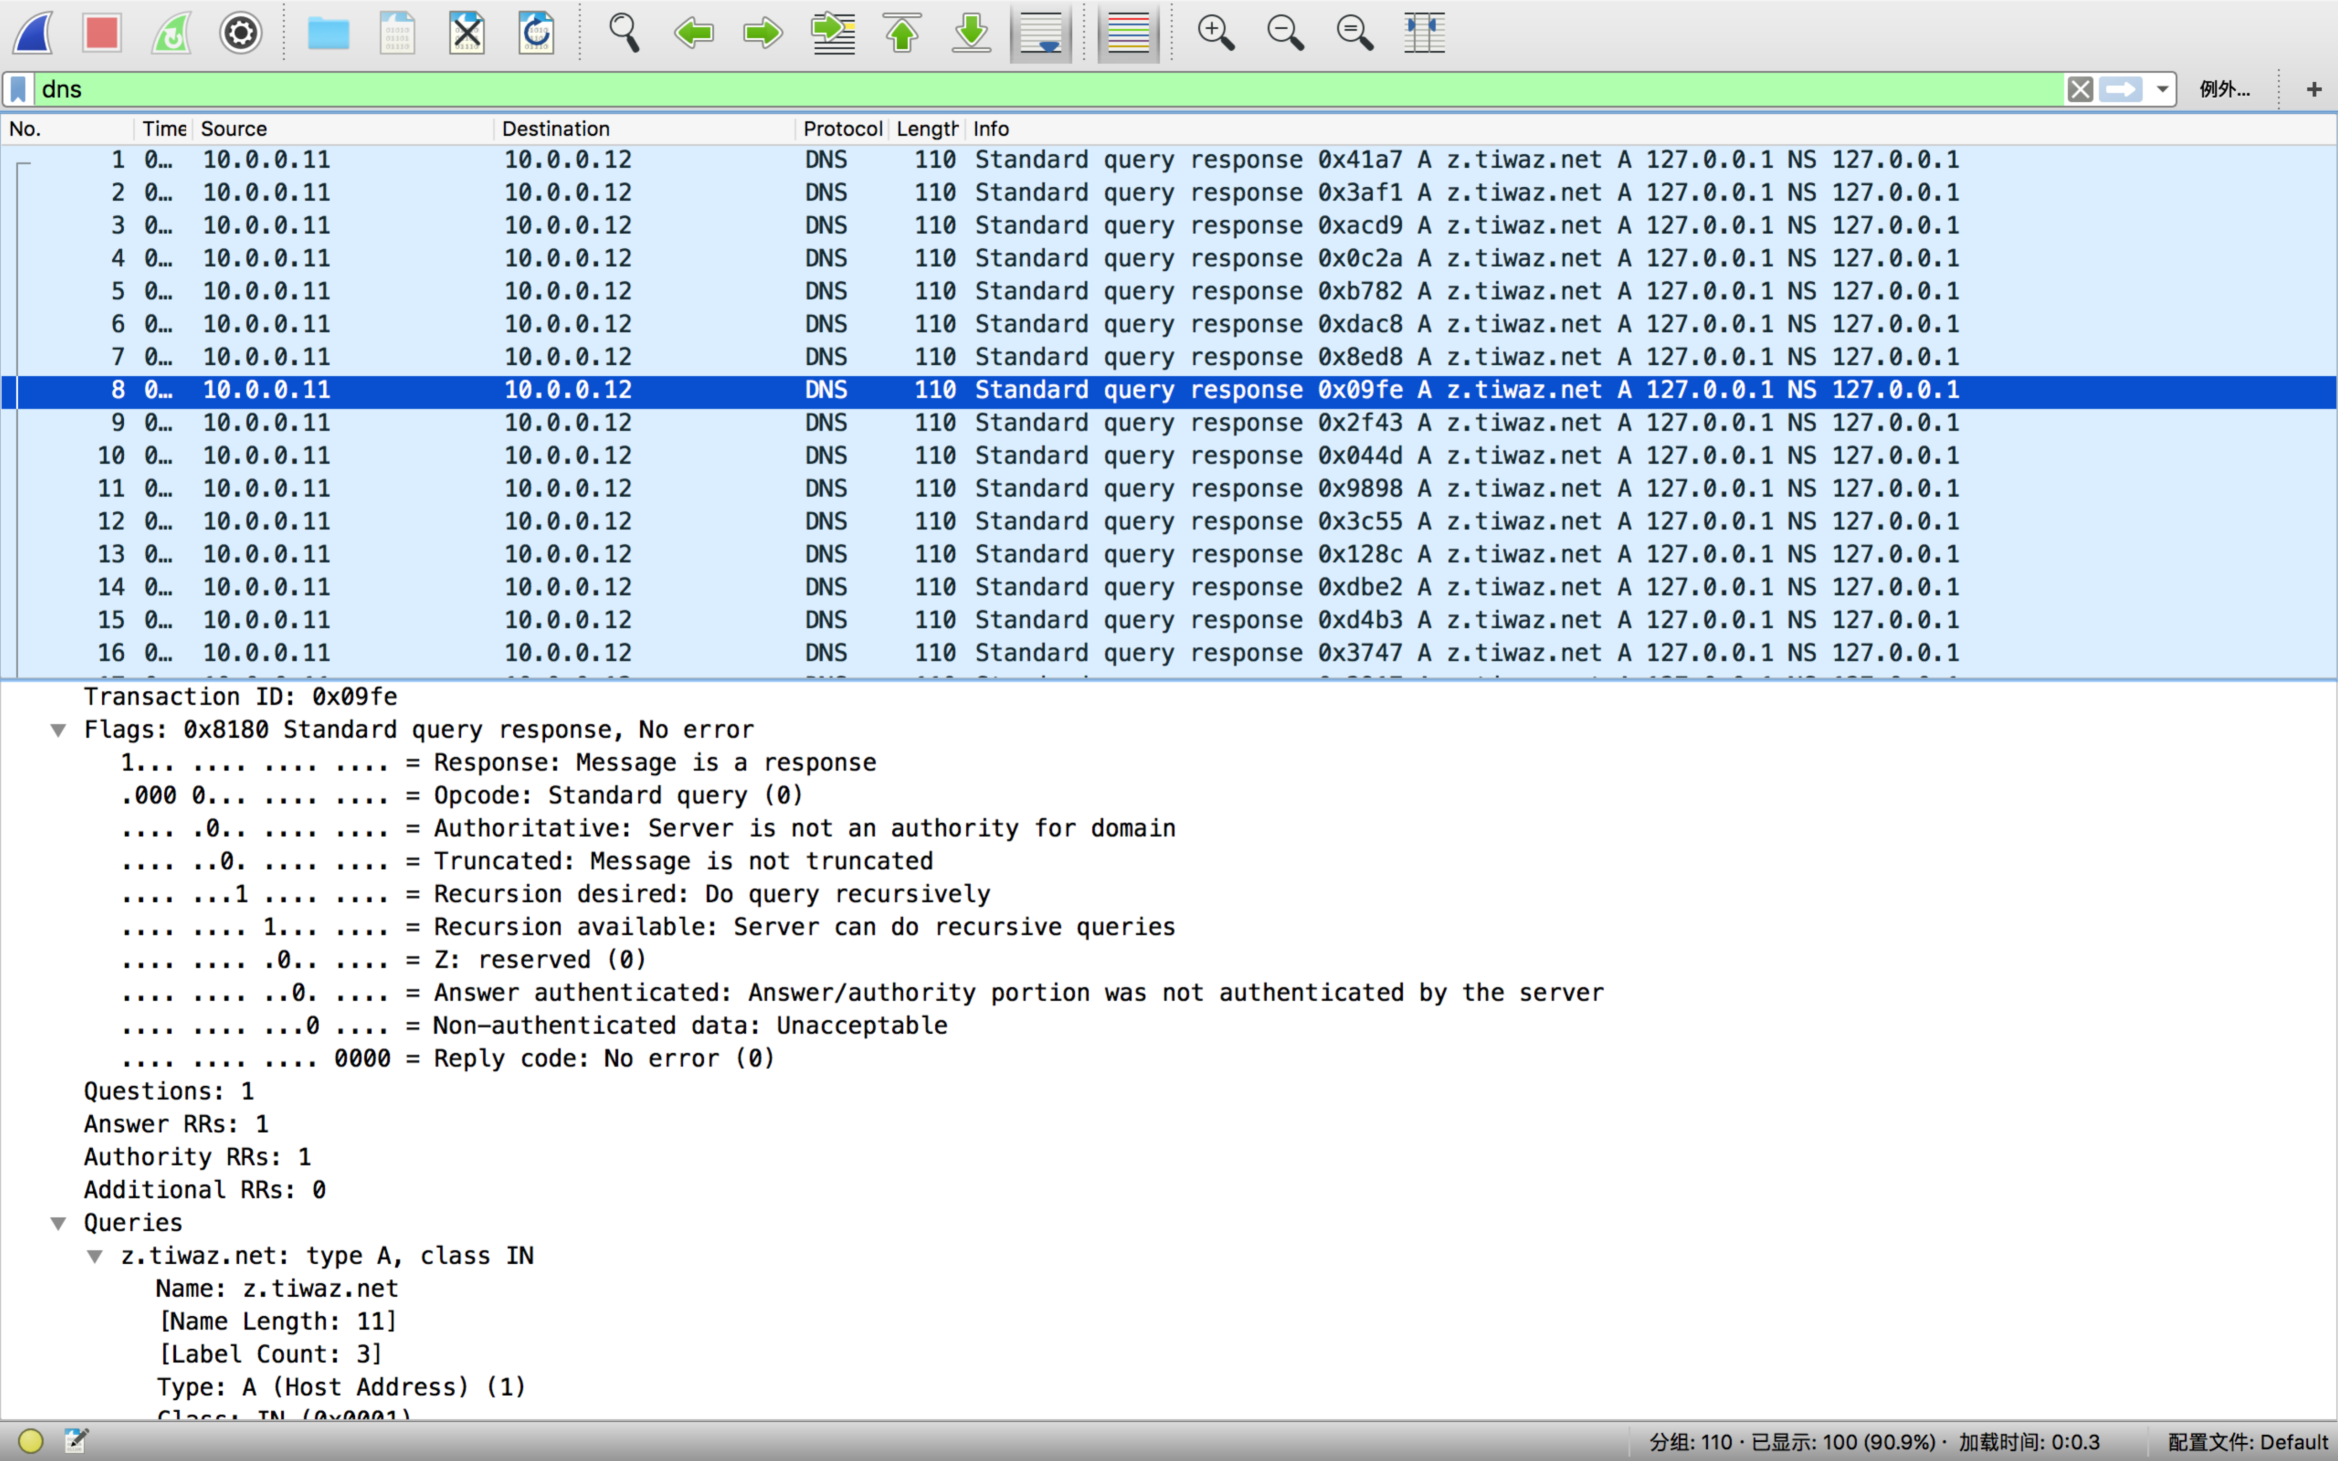

5.

First, we need to install snort and configure it. I use brew to install it.

brew install snort

Then we need to configure the snort.conf file. I will attach the file in my submission.

We need comment several lines and add one line in the given .conf file to run our own .rules file.

For my computer, I use absolute path to do the task. I just put the following line in the .conf file. The myrule.rules file is on my desktop.

include /Users/yixinyin/Desktop/myrule.rules

I also need to put the .conf file to the usr/local/etc/snort directory.

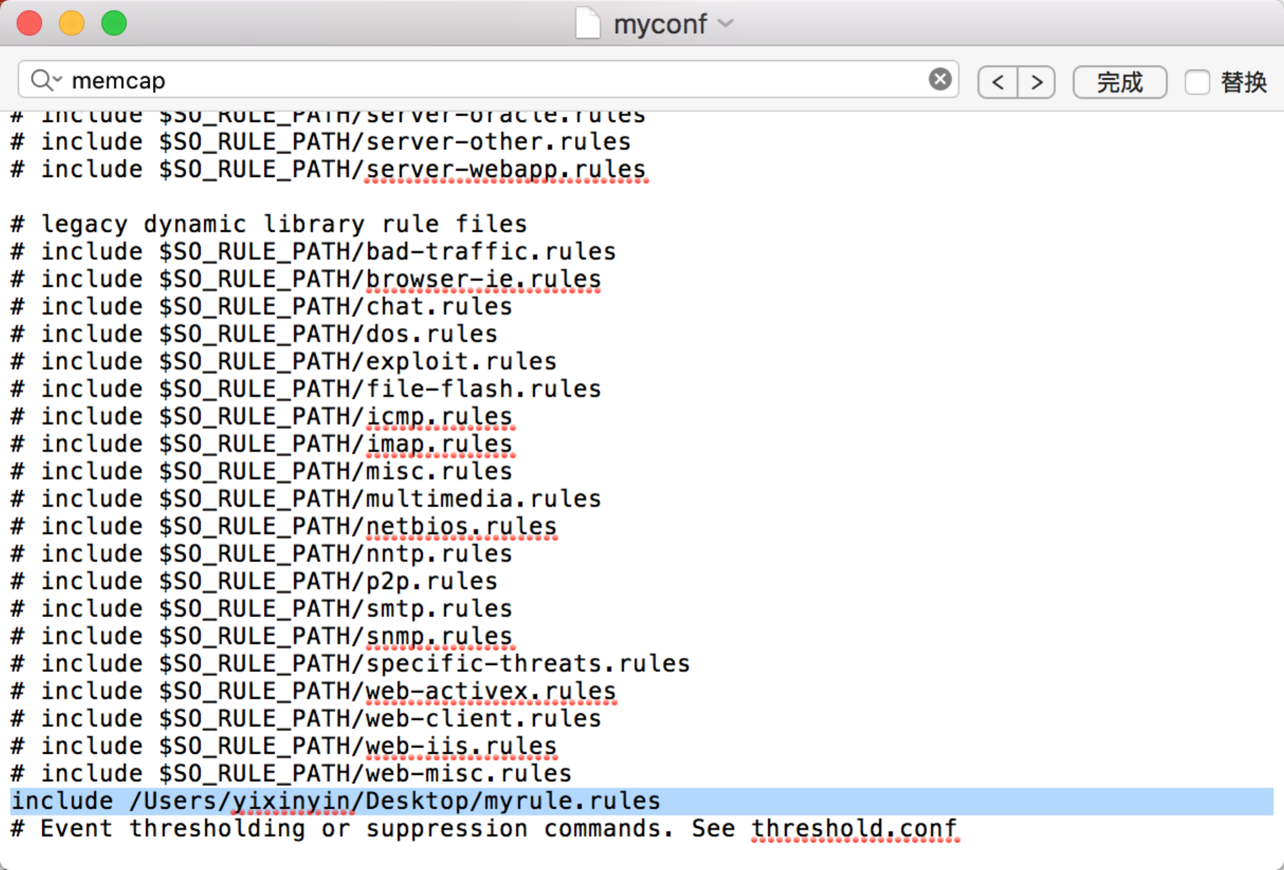

After that, I can define my own rules to get the packet I want.

Then we need to find the indicator in the pcap file to identify the traffic.

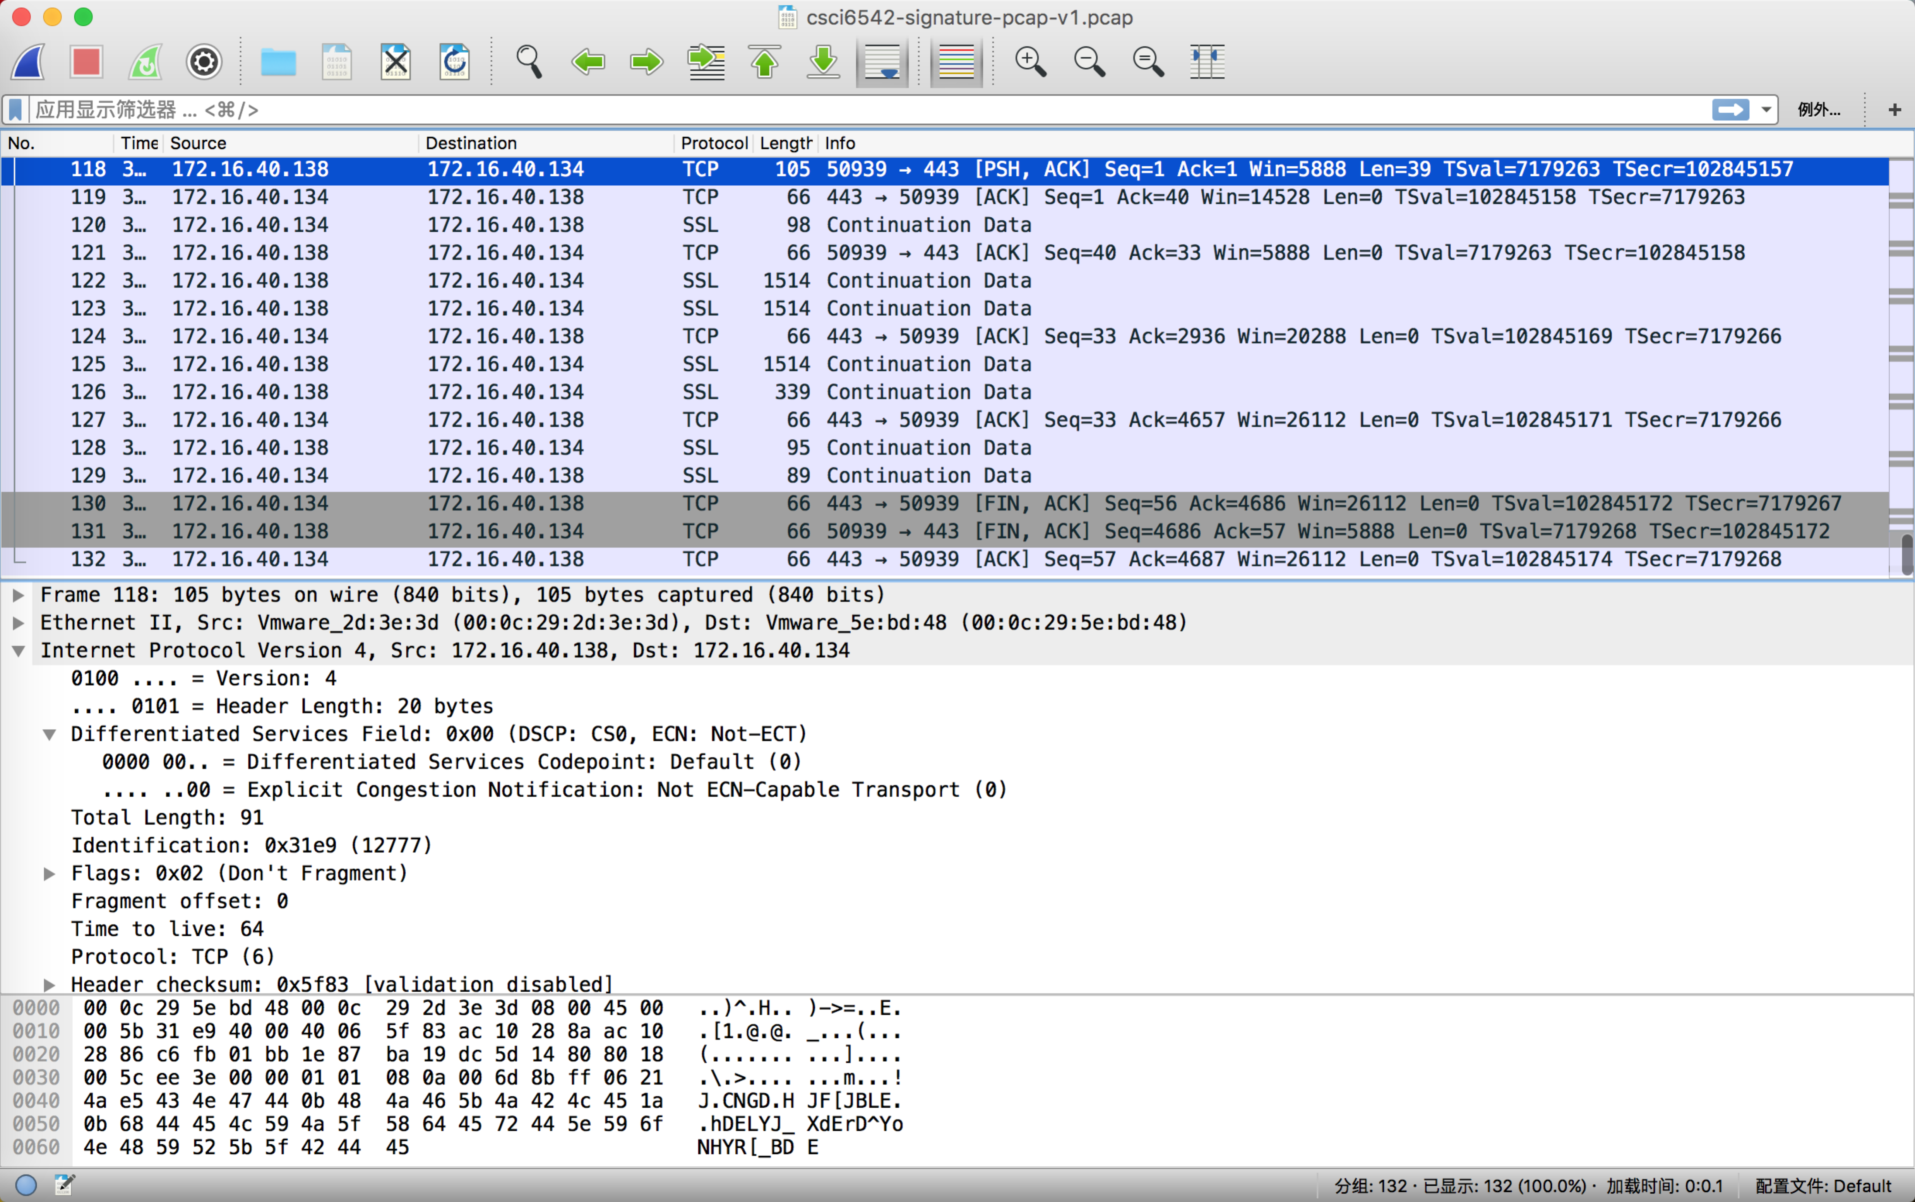

There are totally 132 packets in this file between 172.16.40.134 and 172.16.40.138.

All based on TCP protocol. I use ip, port, ttl and don’t fragment to identify the traffic

alert tcp 172.16.40.134 443 -> 172.16.40.138 any (fragbits:D;ttl:64; msg: “Out Stream“;sid:1000002)

alert tcp 172.16.40.138 any -> 172.16.40.134 443 (fragbits:D;ttl:64; msg: “In Stream“;sid:1000001)

Here is the result when I run the rule.

snort -r csci6542-signature-pcap-v1.pcap -A console -c /usr/local/etc/snort/myconf.conf -k none

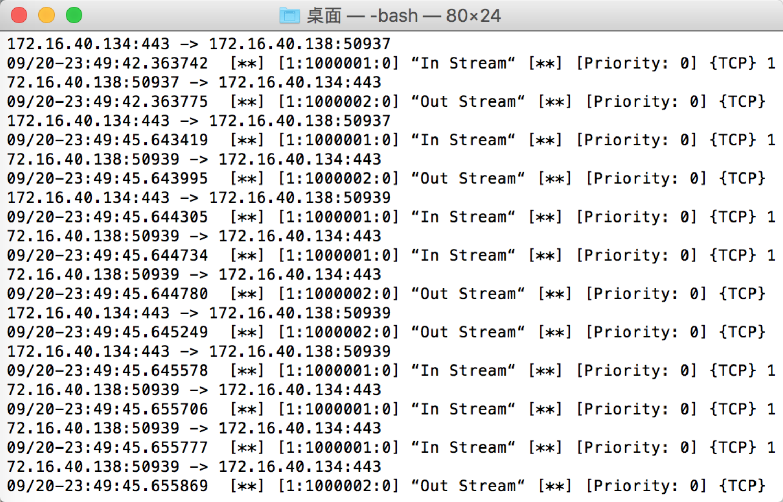

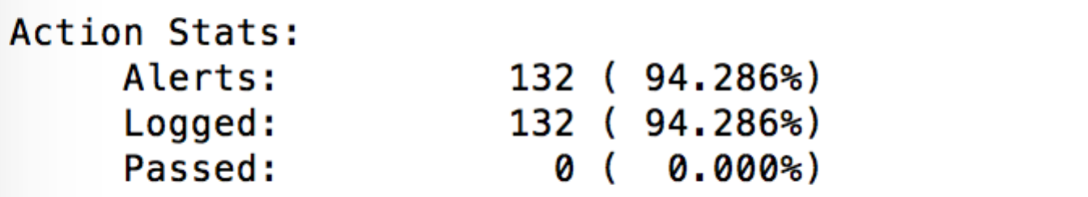

all 132 packets were alerted.

6)

I think it uses SSL to encrpty the data. But I do not have a private key, so I don’t know how to decode it.

7)

because I use mac system, so first I need to link the following library to the project to use libpcap.

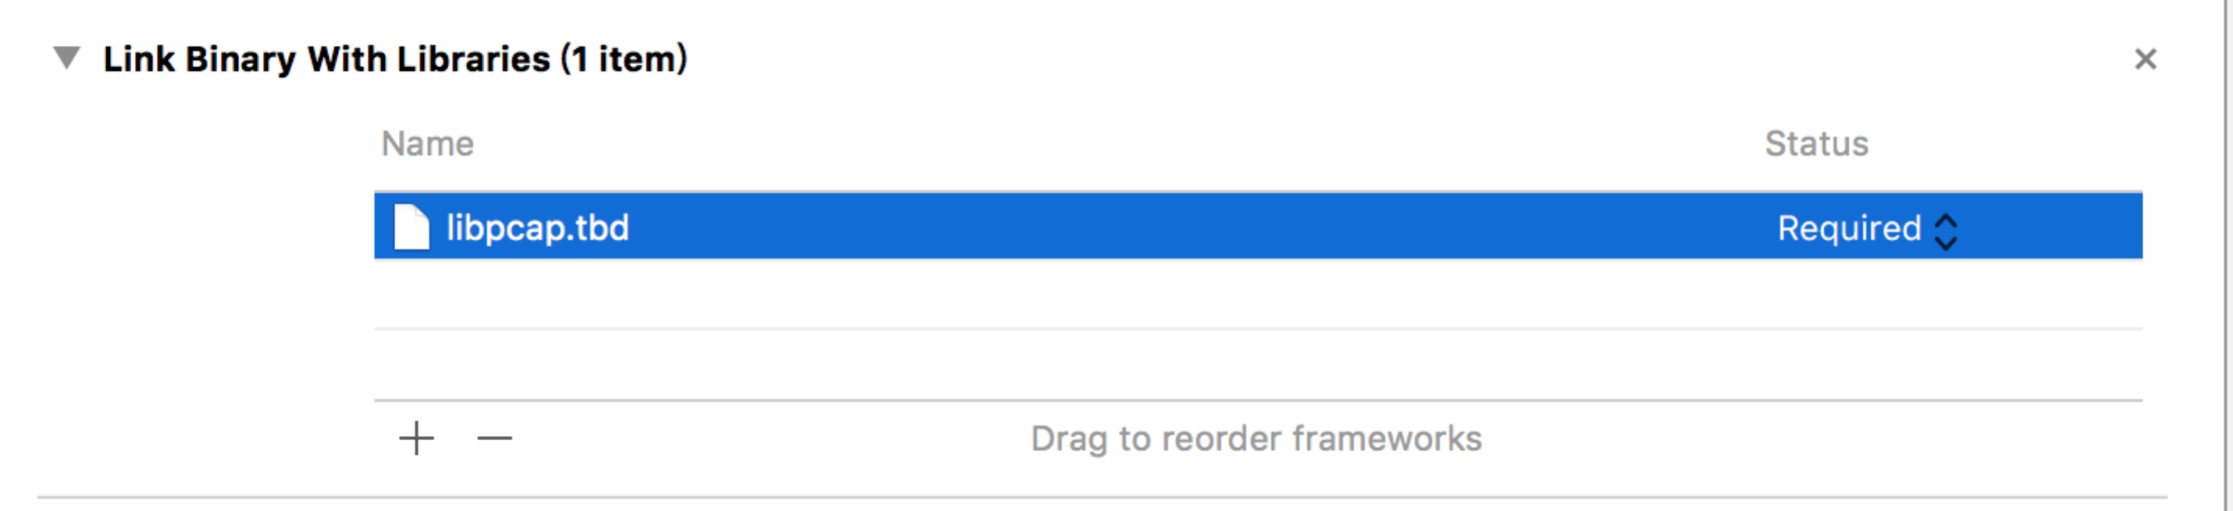

the code is highly based on <http://www.tcpdump.org/pcap.html>

The author writes a pretty specific code and it works successfully. I read it and try to change it a little bit.

So the file structure looks like the following picture:

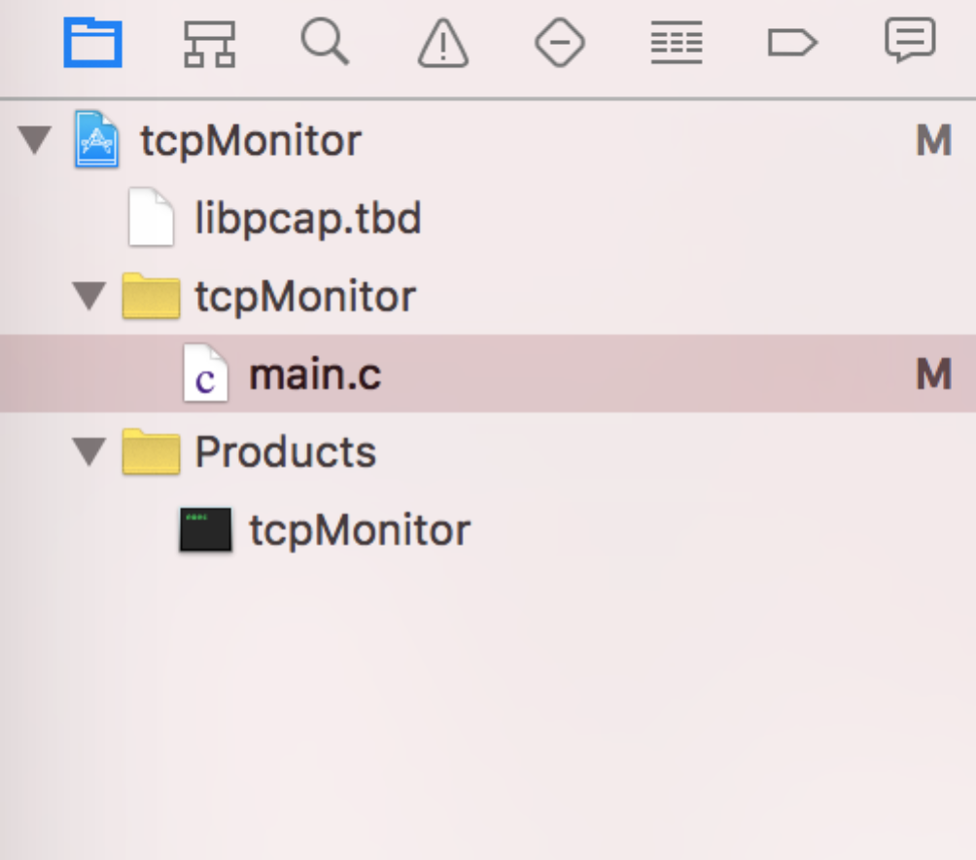

the program works as the following way.

When it starts, it shows the device interface, the maximum number of packets to be monitor and the filter keywords.

Then it asks you to press any key and a enter to check the packet.

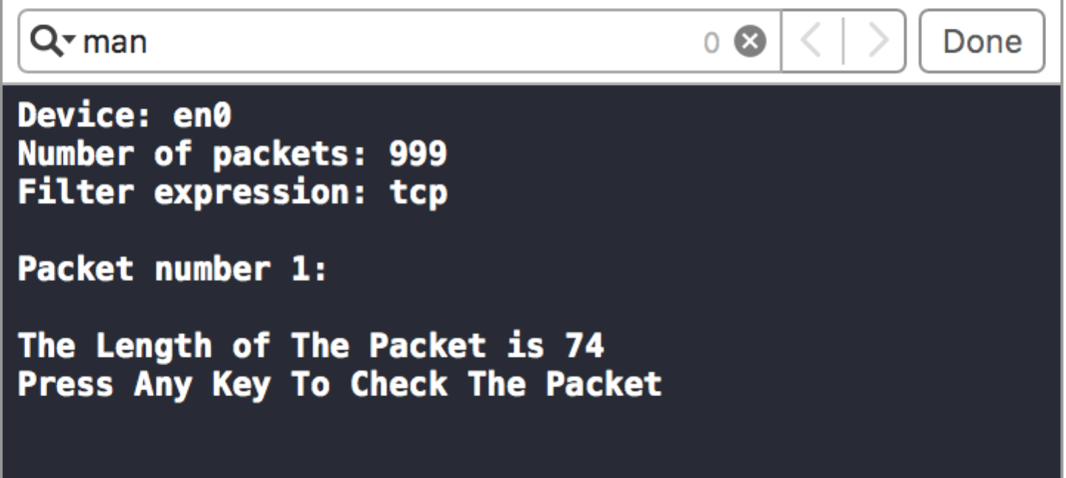

Then we get the following results:  
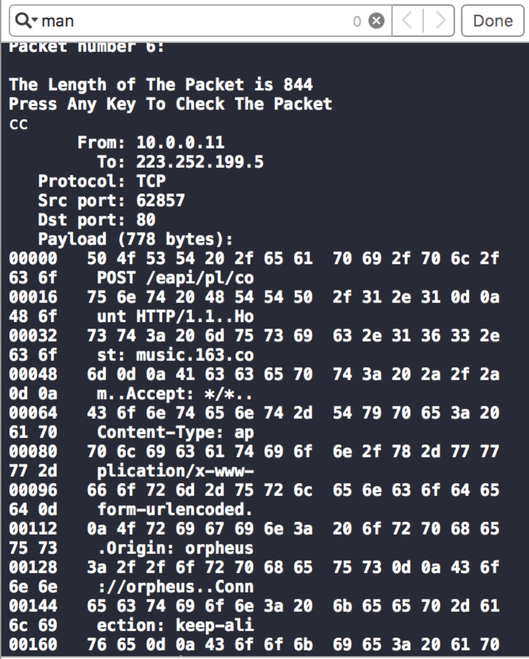

When we input “yyx”, the program will stop because we call exit(0) in the code.

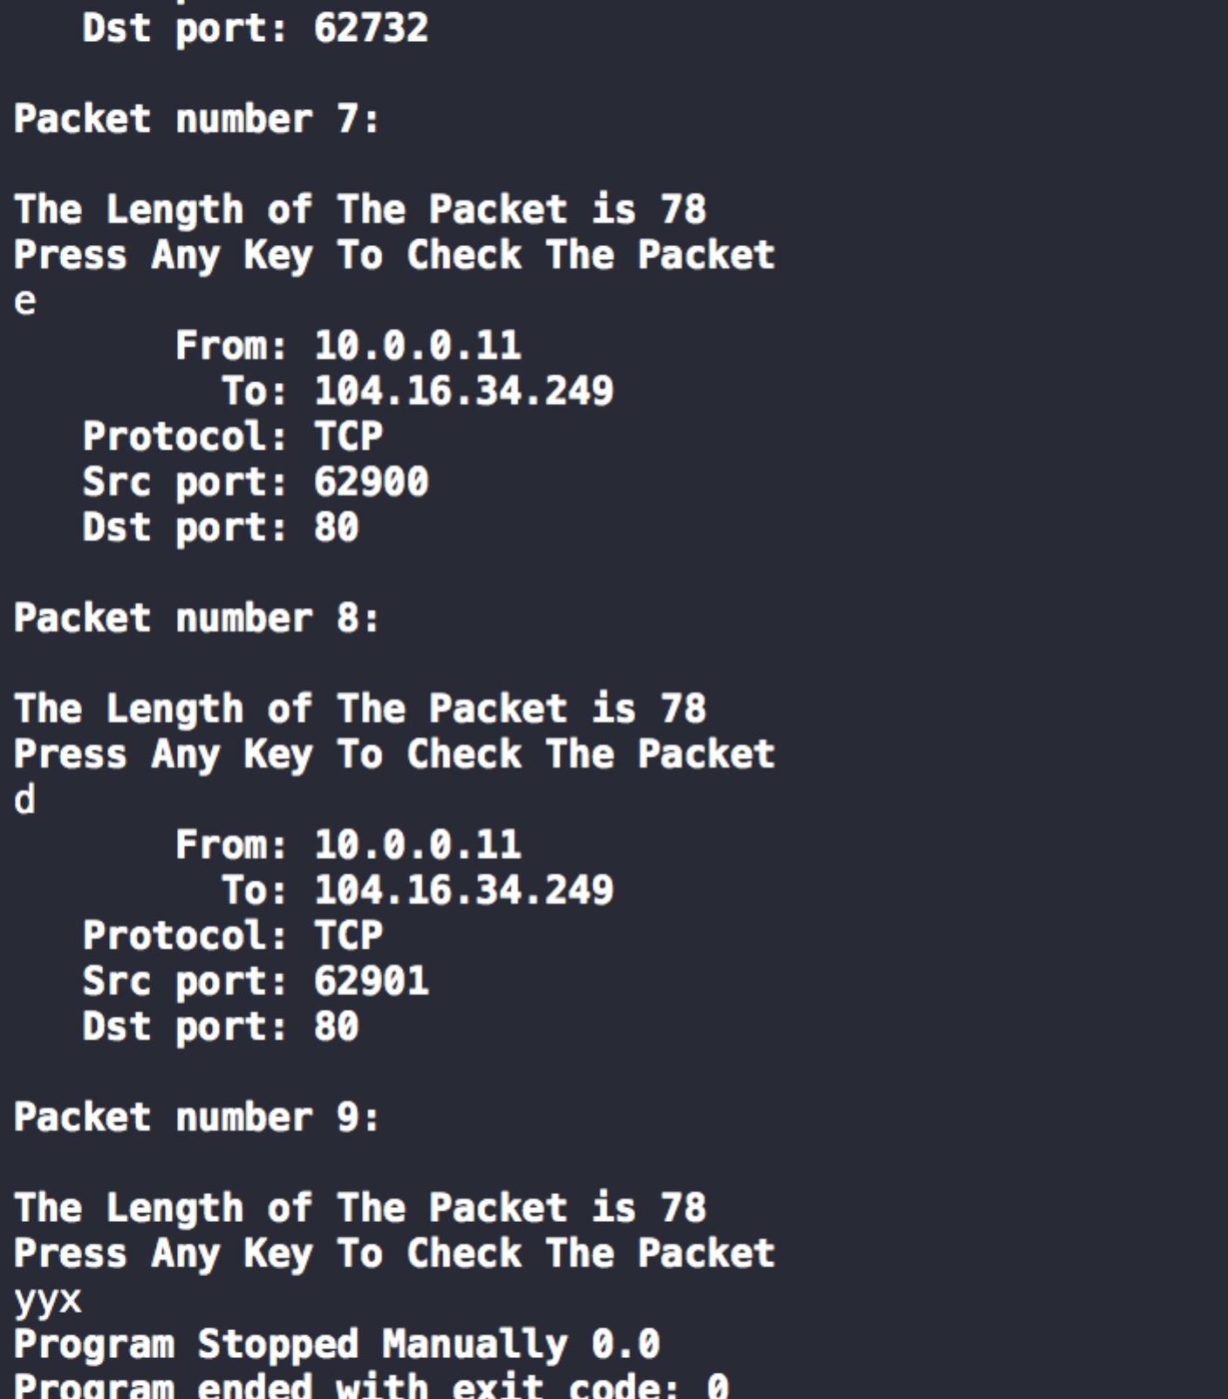

in this way we could disrupt the tcp monitor as we want. We could also run the program in command line.

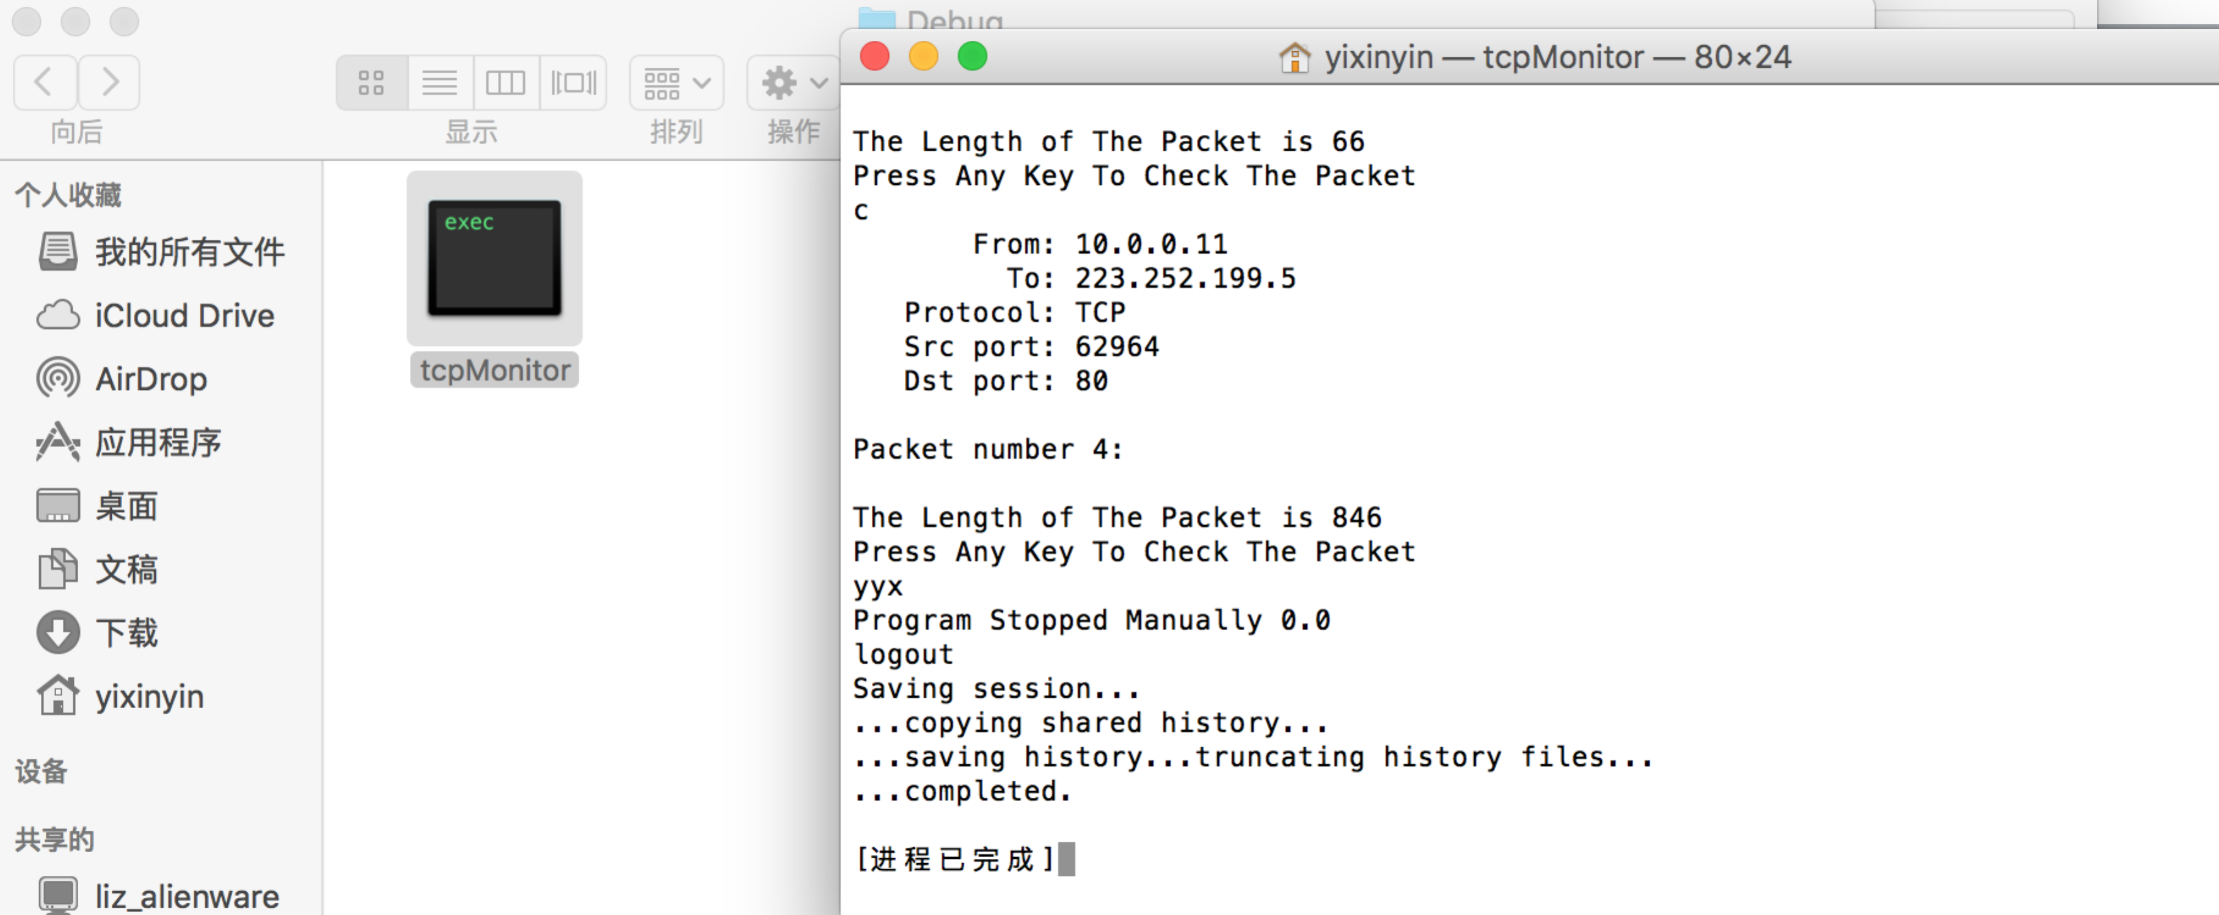

Finally we use the tcpdump command to get the pcap file.

sudo tcpdump -s 0 -w yinyixin_homework5_lab7.pcap

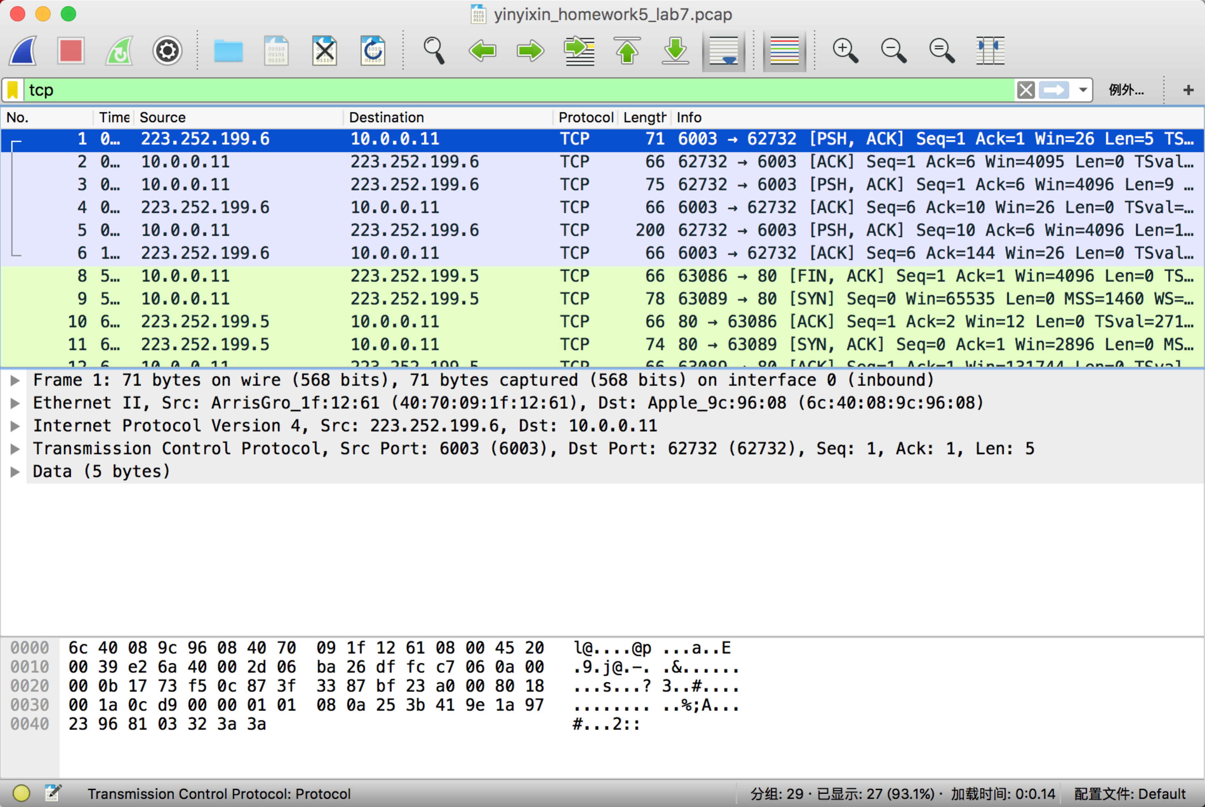

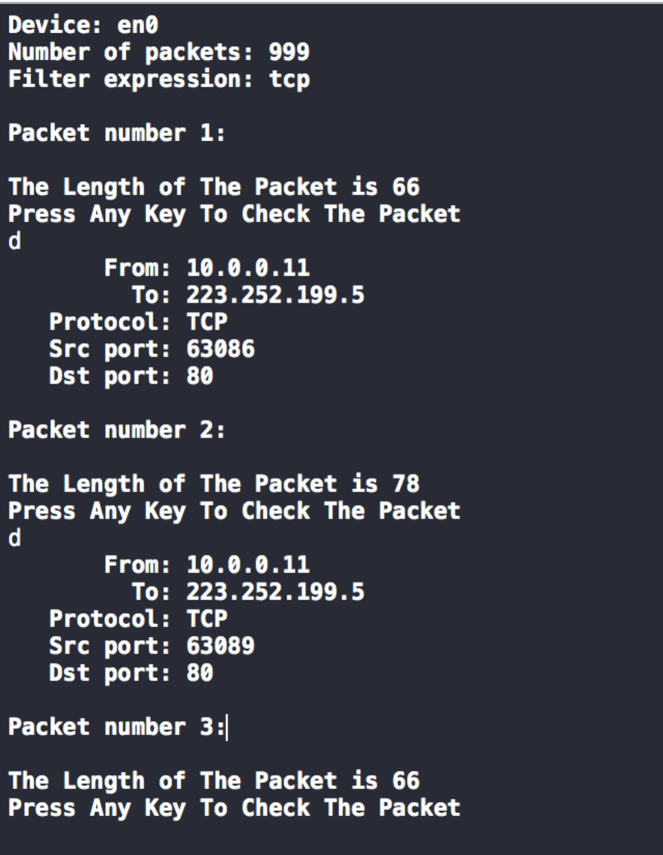



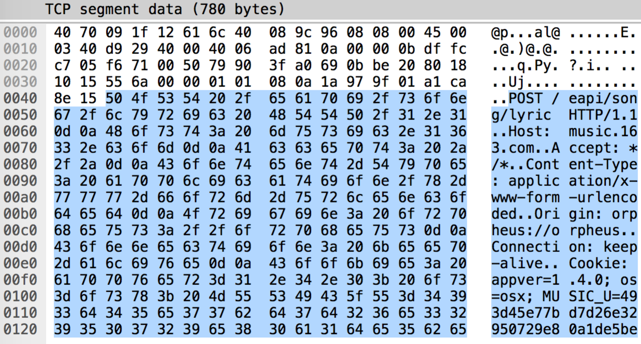

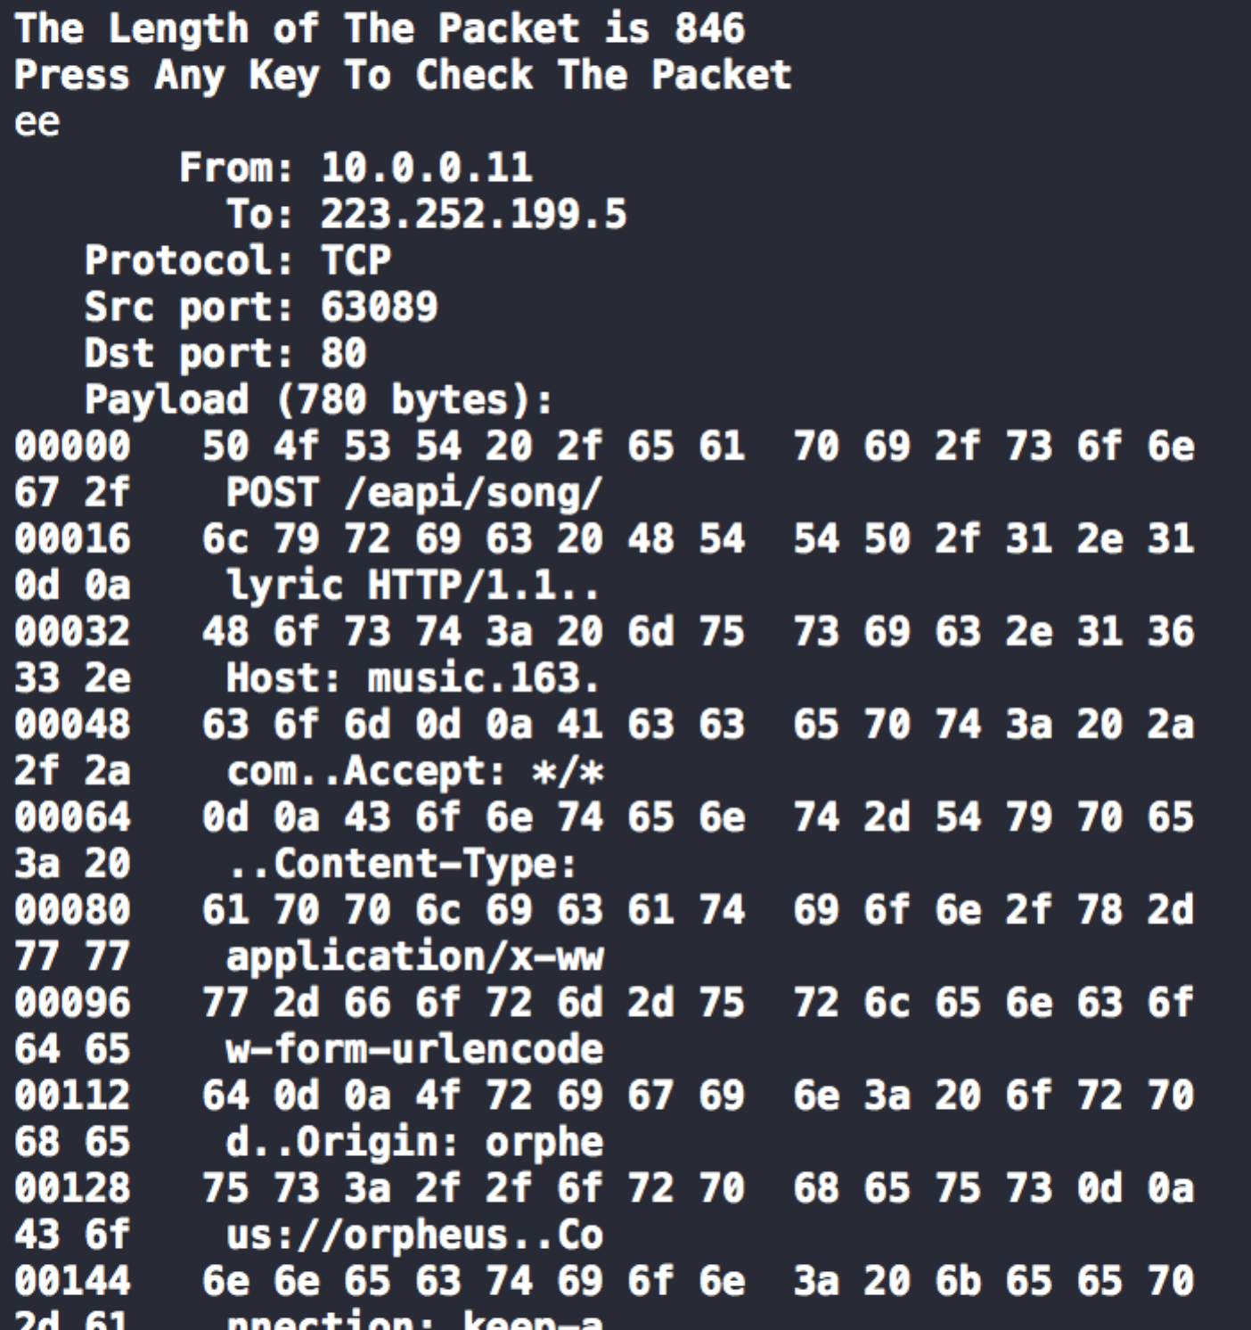

we compare the result we get in our program and wireshark, we could see that the result is the same. So we finish our tcp monitor.

8.

I think the steps are like the following description:  
First we need monitor DNS request and get the transaction id and query domain.

If the query is on“www.google.com” , then we make a fake dns response, we need to set the transaction id as the id in dns query. We also need to set the answer address as what we want.

In that way, the real dns response is replaced by our fake dns response. So I just list how far I go.

This is my IP address.

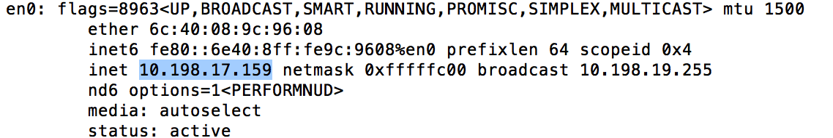

Then I try to make a spoofing DNS response for z.tiwaz.net and redirect it to [www.google.com(74.125.22.105](http://www.google.com(74.125.22.105))

Here is the packet I got by tcpdump.

sudo tcpdump -s 0 -w yinyixin_homework5_lab8.pcap

Here is the screenshot of the DNS packets.

Condition 1: My DNS response came earlier

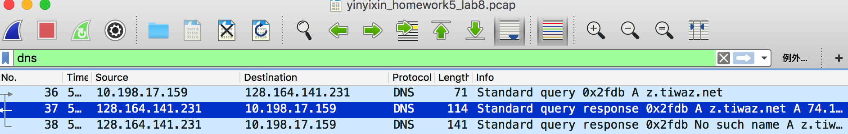

Condition 2: Real DNS response came earlier

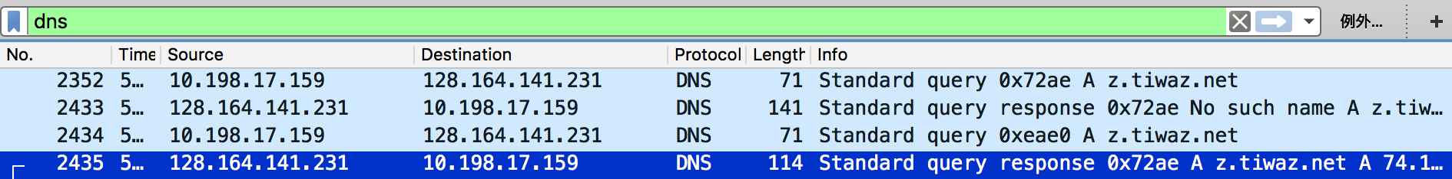

we could see that there are 2 DNS responses with the same transaction id 0x2fdb. The No.37 packet was generated by my codes and the No.38 packet was the real DNS response. I try to fake it but nothing happened. So I’m not sure where is wrong. Sometimes the real DNS response will go earlier than the DNS response I generate. I also can not assign the source mac address in my code because I use mac laptop. I don’t know why it is like that. Maybe you can tell me what is wrong with my implementation.





Furthermore I got the result of the last assignment to hack the NTLM hash.

Since the longest password I set is “computernetworkdefense”.

Its length is 22, and the website successfully decrypt it. Since the length is right, I will not buy it.

